November 28, 2018 FINAL REPORT
Using Administrative and External Data Sources to Model First Term Attrition of Army Enlisted Soldiers

Principal Investigator: Sallie Keller, Social & Decision Analytics Division in the Biocomplexity Institute & Initiative of University of Virginia
Research Team:
Josh Goldstein, Social & Decision Analytics Division in the Biocomplexity Institute & Initiative of University of Virginia
Bianica Pires, Social and Decision Analytics Laboratory in the Biocomplexity Institute of Virginia Tech
Dave Higdon, Social and Decision Analytics Laboratory in the Biocomplexity Institute of Virginia Tech
Stephanie Shipp, Social & Decision Analytics Division in the Biocomplexity Institute & Initiative of University of Virginia

Abstract

A three-fold strategy is described and executed for carrying out a broad-scale analysis of attrition of first term Army enlisted Soldiers. This strategy 1) combines a wide variety of DoD, Federal, and open data sources within the Army Analytics Group (AAG) Research Facilitation Lab’s (RFL) Person-Event Data Enclave (PDE) to produce detailed information over a 15-year period (2001–2015), 2) adapts a Bayesian hierarchical discrete-time hazard model to handle these data that involves over 80-million transactions, and
- produces an analysis of factors that affect attrition over this time period. This effort is substantial in that it has brought together a broad collection of data sources within the PDE to inform the Army about the state of attrition of enlistees who leave before their first term ends. While this collection of data likely holds rich detail regarding attrition, its size and structure makes it difficult to fully extract this information. Hence we use a discrete-time Bayesian hierarchical modeling approach that makes it possible to extract detailed effects from these data while accounting for the uncertainty and dependence within the data. This model is described and then applied to these data to carry out an analysis of first term attrition of Army enlistees.
Keywords: proportional hazards, Markov Chain Monte Carlo, administrative data, non-parametric effects.

Using Administrative and External Data Sources to Model First Term Attrition of Army Enlisted Soldiers

EXECUTIVE SUMMARY

Research Requirement

This effort develops research approaches to combine available DoD transactional records with fed- eral and other open data sources to provide insights that go beyond those typically obtained from single-source analyses based on a restricted collection of Soldiers. This research was demonstrated on a large-scale study of first-term attrition for enlisted Army Soldiers. This effort includes data discovery, data quality and fitness assessment, creation of intermediate data products, and devel- opment of statistical modeling approaches to handle this broad collection of data.

Procedure

A three-fold strategy is executed for carrying out a broad-scale analysis of attrition of first term Army enlisted Soldiers. This strategy
  - combines a wide variety of DoD, Federal, and open data sources within the Army Analytics Group (AAG) Research Facilitation Lab (RFL) Person-Event Data Enclave (PDE) to produce detailed information over a 7-year period (2009–2015),
  - adapts a Bayesian hierarchical discrete-time hazard model to handle these data that involves over 80-million transactions, and
  - produces an analysis of factors that affect attrition over this time period.

This effort is substantial in that it has brought together a broad collection of data sources within the PDE to inform the Army about the state of attrition of enlistees who leave before their first term ends. While this collection of data likely holds rich detail regarding attrition, its size and structure makes it difficult to fully extract this information. Hence we use a discrete-time Bayesian hierarchical modeling approach that makes it possible to extract detailed effects from these data while accounting for the uncertainty and dependence within the data.

Findings

It is feasible to leverage a broad array of data sources (from DoD and beyond) for addressing particular research questions. A number of new processess have been established within the Army Analytics Group (AAG) Research Facility Lab (RFL) to streamline the ingestion of new data sources in their Person-Event Data Enclave (PDE). Assessing fitness for use of different data sources is labor intensive, and typically depends on the specific use-case.

Software and computing infrastructure now exists within the AAG RFL PDE to carry out rather complex statistical analyses using these combined data sources. The special nature of these data sources can make the details of the statistical modeling quite complex.
The demonstration analysis on attrition has found a slight, but increasing temporal trend in the attrition risk over this 7-year period. At the individual level, length of service, number of deployments, and rank show a strong association with attrition; disciplinary actions (e.g. Article 15, letters of reprimand) were also positively associated with attrition. Effects related station location (base) as well as unit associations also show an association to attrition, albeit at a weaker level. The proportion of Veterans in the duty station location is negatively related to attrition rate; the proportion of households receiving SNAP was was positively related to attrition rate (Figure 13).

Utilization and Dissemination of Findings

Data and derived data products from this effort are now available for all researchers within the AAG RFL PDE. Majors A. Smith and J. Shingleton from TRADOC were able to access these resources for their study within the PDE.
Results from this effort have been presented at 2018 Research and Policy Conference of the Federal Committee on Statistical Methodology on March 8, 2018.

Contents
- Introduction 6
- Overview of Literature on Attrition 6
- A Stylized Simulation Model and Statistical Analysis of Attrition 8
- Application to first term attrition of enlisted soldiers 17
- Discussion 27
  - Accessing and Using the Person-event Data Environment 36
  - Review of Literature on Attrition and Related Topics 40
List of Figures
    - Trajectories of individual enlistees in this agent-based model. 9
    - Specified term effect encoded in β₂ of the attrition ABM. 11
    - Crude attrition calculated from the entire ABM output. 12
    - Five posterior realizations produced by the MCMC scheme. 15
    - Posterior 95% intervals for the unit effects and the term effects of the ABM. 16
    - Fitted relative hazard rate for gender, race, education tier, and age. 20
    - Fitted relative hazard rate for rank. 21
    - Fitted relative hazard rate for years of active service, calendar year, and MOS 21
    - Fitted relative hazard rate for AFQT, APFT, and body composition test. 21
    - Fitted relative hazard rate for Courts Martial, Article 15 proceedings, and Letters
of Reprimand. 22
    - Fitted relative hazard rate for the number of times, and cumulative number of days
a Soldier has been deployed. 22
    - Fitted relative hazard rate for the unit to which a Soldier currently belongs. 23
    - Fitted relative hazard rate for effects of the community surrounding the duty location
of a Soldier 24
    - Posterior density estimate for the standard deviation σ₁, corresponding to the ran-
dom effect for Soldiers. 24
    - Data Science Framework 40
    - Data Source Map 42
    - Data Profiling Example showing distribution of rank. 43

List of Tables

- Structure of agent-based model output simulating attrition. 10
- Structure of the transaction table data product. 18
- Table of fitted covariates for the baseline Cox Proportional Hazards model. Estimates and 95% confidence intervals are reported. Coefficients have a statistically significant
impact on the attrition hazard when the confidence interval excludes 1. 26
- Data Sources acquired for research to model attrition of enlisted Soldiers. 41
- Positive Correlates for Burnout. 45
- Correlates of Turnover. 48

Introduction

This effort was conceived as a proof of principle, as well as a legitimate attempt to study attrition from a broad perspective, using multiple sources of data, not just a single or few sources of data that is the traditional approach. The proof of principle focused on working within Army Analytics Group (AAG) Research Facilitation Lab’s Person-Event Data Environment (PDE) and combining data sources – DoD personnel records, transactional records, mental and physical test outcomes, and federal data sources (U.S. Census Bureau’s American Community Survey, Bureau of Labor Statistics) – to provide information about a Soldier and his/her local environment. The analysis component of this effort centers on adapting statistical methodology to leverage the broad collection of data sources to improve understanding about attrition of Army enlistees. This technical report focuses on the statistical methodology and the resulting analysis based on these data that have been collected.
This analysis differs from more common attrition analyses based on a sample from a single historical database or a sample from a single historical database (for example, (Buddin, 1988; Asch et al., 2010; Burkhauser et al., 2014; Hoge et al., 2002; Niebuhr et al., 2009). Here we develop a broad-based analysis that
  - combines multiple data sources to build a substantial transactional database for soldiers and their environments over the time period from 2009–2015,
  - adapts a Bayesian discrete-time hazard model (King, 2014) to analyze this dataset (nearly 1 million Soldiers and 80-million transactions), accounting for a wide variety of covariates at the individual, unit, and environmental level, and
  - carries out an analysis of first-term attrition using data to estimate the impact of various effects, including test scores, local economic indicators, unit, service time, and disciplinary record.
In the following sections we describe the basic modeling and analysis approach. First, we describe a stylized system in which we simulate Soldiers’ unit and attrition status over their first enlistment. This gives us an opportunity to motivate and describe our statistical analysis approach. The details of this analysis is presented in Section 3. Section 4 describes the results from a detailed analysis of attrition in first-term enlisted Soldiers. Our use of different DoD and federal data sources, combined with modern, flexible and efficient statistical modeling and estimation, allows us to include outcomes and covariates for nearly 1 million Soldiers over the 2009-2015 time period.

Overview of Literature on Attrition

Attrition, as defined by DOD, refers to a loss in personnel that leads to a reduction in the effec- tiveness of the military force. It is an important issue for the military because it is a major driver

of personnel costs (Vie et al., 2013). The central focus of research on attrition has focused on: 1) factors that lead recruits and enlistees to leave military service, and 2) time dependent rates of loss conditioned on these factors (DoD, 2012). There is no single, comprehensive definition of attrition in the literaturethe definition depends on the research question of interest. Below is a summary of the types of attrition (Buddin, 2005):

  - Delayed Entry Program (DEP) attrition

  - Fitness program participation (for recruits who fail the initial fitness exam)

  - Basic Combat Training (BCT) attrition

  - Early attrition (separation in the first 6 months)

  - First-term attrition (separation in the first 36 months)

  - First-term promotion to sergeant

  - First-term reenlistment

The type of attrition under study affects the factors of interest, the time horizon of interest, and the data employed. For example, premature attrition occurs during training with new enlistees (Manacapilli et al., 2012; Larson et al., 2008; Niebuhr et al., 2013)
First-term attrition refers to a separation from the military that happens before the end of the Soldiers first term and is not considered a reenlistment, transfer to officer, or an extension of term (Asch et al., 2005, 2010, 2013; Kubisiak et al., 2009; Buddin, 2005). Some work focuses on length of service (Burkhauser et al., 2014) or involuntary separation or discharge due to medical concerns (Niebuhr et al., 2008; Hoge et al., 2002, 2006; Wilson et al., 2009).
A core feature of the military attrition literature is the dearth of research that is anchored in military contexts. Instead, there is a focus on individual characteristics, such as the type of high school degree received, the Armed Forces Qualification Test (AFQT), and sometimes training and occupation factors. These data are often cross-sectional or limited to a specific timeframe.
As a first step towards studying this problem, we examined the literature on attrition from the DoD, the US Army, other military services, and the civilian sectors from the helping professions, management, and education. This review, along with discussions with experts from DoD, the Army, and the civilian sector, informed the choice of variables in the models. Appendix B provides a summary of literature review delivered to ARI in December 2016 (Shipp et al., 2016).

A Stylized Simulation Model and Statistical Analysis of Attri- tion
To explain the statistical modeling approach used in this application, we first describe a stylized system in which we follow Soldiers in their first enlistment. This is encoded in an agent-based model (ABM) that simulates 10 years of enlistments and attritions. This controlled, synthetic system allows us to encode simple, probabilistic rules that affect attrition. For example, the ABM can assign different attrition probabilities based on unit, or time of service. More generally, the ABM could modify the attrition probability of a Soldier depending on the quality of his or her leader, social connections, or past history. For this document, we use this ABM to produce records that are similar to records we obtain from the transactional data used in this larger study, giving us an opportunity to develop and test statistical methodology that is suitable for data of this size and form.
We simulate quarterly data collected from this ABM, and then describe a Bayesian model developed in King (2014), used to estimate the effect of different variables on attrition. This approach generalizes the standard (Cox, 1972) model to handle multiple time scales (e.g. year and time of service), random individual effects (e.g. and individual’s tast for military service), and flexible, non-parametric specifications for continuous effects (e.g. age, days deployed). Section
3.1 gives the details of this ABM and Section 3.2.2 describes the Bayesian model in some detail, including the prior formulation, the resulting posterior distribution, and the use of Markov chain Monte Carlo to produce samples from this distribution. Finally, we show how these samples can then be summarized to produce estimates of the unit and term effects, and measures of their uncertainty. This should facilitate understanding of the full analysis which uses a more complicated form of the statistical model described in Section 4.

The Stylized Agent Based Model
The ABM simulates enlistment histories for 100,000 individual Soldiers over the course of 10 years. Soldiers enlist at random times distributed uniformly over the course of 10 years. Each Soldier either serves the full 3-years of the term, or else drops out (attrits) prior to the end of their first full term. Because the Active Duty Military Personnel Transaction file updates quarterly, and because this is a key data source used in the large analysis of Section 4, the ABM updates every quarter as well. Figure 1 shows the simulated histories of a collection of 25 enlistees over course of the 10-year (40 quarter) simulation.
For this demonstration, we specify that the attrition probability for any Soldier at any given time depends only on two factors:
    - the unit in which the Soldier is currently serving; and

simulated enlistee trajectories
● ●
● ●
● ●
● ●
●
● ●
●
●
● ●
● ●
- completed term attrit
color=unit
time (quarters)
20
30
40

0 5 10 15 20 25
0
10

individuals

Figure 1: Trajectories of individual enlistees in this agent-based model. Each vertical line shows a Soldier’s history
- the line begins at the time of enlistment, color shows the Soldier’s unit assignment over time, and the plotting symbol shows whether or not the Soldier attritted or served out his/her initial 3-year term.

  - the amount of time the soldier has already served in his/her first enlistment term.

Thus for any given time (quarter) t, it is sufficient to record each individual currently in the Army i, their unit at time t, u(i, t), the amount of time the Soldier has served in their enlistment τ (i, t), and whether or not that individual has attritted at this time y(i, t). As an example, Table 1 shows a subset of the ABM output corresponding to individual i = 438. The individual first enlisted at time t = 5, and was assigned to unit 17. In the 5th quarter of his/her enlistment term (and the 9th quarter of the simulation, t = 9) the individual was reassigned to unit 5. In the 6th quarter of his/her enlistment term, the individual attrits from the Army (at t = 10). Had the individual not attritted, his/her term would have ended after the 12th term at t = 16. The output file then gives information about the next individual (i = 439) in the ABM simulation.
Any Soldier i in his/her first enlistment term who has not attritted prior to time t is at risk of attritting at time t. We take the discrete time hazard
p_{it} = Pr (y(i, t) = 1|y(i, t ) = 0 for t < t (1)
to denote the probability that Soldier i attrits at time t given he/she was still serving his/her first enlistment term prior to time t. The ABM models the discrete time hazard according to the

Table 1: Structure of agent-based model output simulating attrition.

time | individual | timeInTerm | unit | attrit
t | i | τ (i, t) | u(i, t) | y(i, t)
: | : | : | : | :
5 | 438 | 1 | 17 | 0
6 | 438 | 2 | 17 | 0
7 | 438 | 3 | 17 | 0
8 | 438 | 4 | 17 | 0
9 | 438 | 5 | 5 | 0
10 | 438 | 6 | 5 | 1
6 | 439 | 1 | 12 | 0
: | : | : | : | :

standard logistic regression equation

logit(p_{it}
p_{it}
) = log = β₀
1 − p_{it}

+ β1 u(i,t)

+ β2 τ (i,t)

. (2)

This uses the common approach of specifying an additive model in the logit space of the discrete hazard probability (McCullagh and Nelder, 1989). Here
  - β₀ is a scalar constant that controls the log-odds of the mean attrition rate,
  - β₁ = (β₁₁, . . . , β_{1n}u ) is a n_{u} = 100-vector of values holding the unit-specific adjustment to the attrition probability (note: there are 100 units in this ABM), and
  - β₂ = (β₂ ₁, . . . , β₂ ₁₂) is a 12-vector that modifies the quarterly attrition probability as a function of time served τ ∈ {1, . . . , 12} in the Soldier’s first (12-quarter) enlistment term.
For this modeling exercise, we set β₀ = −3.8, set each component of β₁ to be an independent draw from a N (0, σ = .3) distribution, and specify β₂ to have a “U” shape as shown in Figure 2. This shape conforms to our expectation that attrition is generally more common near the beginning and end of the first enlistment term. This is born out in the full analysis given in Section 4.
In the ABM, a Soldier i will enlist at time t, at which time his personal time in term τ (i, t) is set to 1. The Soldier serves in unit u(i, t). In this first quarter the Soldier has an attrition probability
of
exp {β0 + β1 u(i,t) + β2 τ (i,t)}
pit(β) = 1 + exp {β
} (3)
0
+ β
1 u(i,t)
+ β
2 τ (i,t)
which follows directly from equation (2). If the Soldier does not attrit, he/she continues to the next time period where both t and τ are incremented by 1. Also, there is a small chance (prob = .01) that the soldier is randomly assigned to a new unit. The value of u(i, t + 1) is updated accordingly. If Soldier i does not attrit over the 12 quarters of his/her enlistment term, the Soldier is removed from the model and a new Soldier is recruited to take his/her place.

0.5
1.0

2 4 6 8 10 12
●
●
●
●
●
●
●
●
●
●
●
●
®₂ ABM term effect
−0.5
0.0

⎮ (quarter in term)

Figure 2: Specified term effect encoded in β2 of the attrition ABM. For each quarter of the 3-year enlistment term, the relative odds of attrition are higher in the beginning and end of the term. This model assigns a common term effect β2 for every individual in the ABM.

Over the course of the 10-year ABM simulation, the number of first-term enlistees is held constant at 30,000. Hence if a Soldier attrits at time t, a new one is recruited at time t + 1. Thus, the number of Soldiers that exit the simulation – by attrition or finishing out the full 3-year term
- is matched by the same number of Soldiers starting their enlistment next quarter. The average attrition rate of about 0.26 gives simulations that produce about 140,000 distinct soldiers over the 10-year simulation period.
The ABM simulation produces a 1.6 million-line transaction file, giving the unit and attrition state of each Soldier over their enlistment term. As a check to ensure that a term-effect (the “U”- curve) is discernible in this random output, we can compute the proportion of attritions for each unit at each of the 12 quarters of the enlistment term. Figure 3 shows the raw attrition rates from the model output. Clearly a term effect is present; the unit effect is less obvious. A principled, statistical analysis will provide a better approach to estimate these effects while accounting for the variation and randomness that is present in these data.

Statistical Modeling of Attrition Effects

Bayesian Modeling

Statistical models most commonly start with a probability model for the observed data y. In the case of attrition, for example, y = (y₁, . . . , y₁₀) might denote whether or not 10 individual Soldiers attrited in the past quarter – thus y_{i} = 1 if the Soldier attrits; y_{i} = 0 otherwise. This probability will typically depend on covariate information regarding the Soldier x_{i}, as well as

0.10
proportion attritted

0.05

0.00
1 2 3 4 5 6 7 8 9 10 11 12
⎮ (quarter in term)

Figure 3: Crude attrition calculated from the entire ABM output. The attrition rate is tabulated by computing the proportion of attritions for each term quarter τ ∈ {1, . . . , 12}, and each unit u ∈ {1, . . . , 100}. A different color is used for each of the 100 units.

unknown parameters β that relate x_{i} to the probability of seeing the observation y_{i}. For attrition, each of the y_{i} can be modeled as independent Bernoulli trials with probability p_{i} that depends on x_{i} and unknown parameters β (see Section 3.2.2 for an example). We take the likelihood function to be the probability density of the observed data L(y|β, x) given the unknown parameter vector β and the covariate information x. The likelihood function is more commonly written as L(β|y), subsuming x in this expression, and reminding us that statistical inference treats the likelihood as a function of the unknown parameter vector β.
Standard likelihood theory (McCullagh and Nelder, 1989; Casella and Berger, 2002) is based solely on the likelihood function. Bayesian modeling requires an additional component – a prior probability model for the unknown parameters π(β). This additional piece makes it possible to describe uncertainty in model parameters and future outcomes using probability; this is contained in the posterior probability density π(β|y). The posterior probability density is computed via
Bayes’ rule
1
π(β|y) = c(y) · L(β|y) × π(β)
J
where c(y) = L(β|y)π(β)dβ ensures that π(β|y) integrates to 1.
Bayesian formulations have proven effective in modeling random effects and non-parametric effects, both of which are prominent in the main attrition models described in Sections 4 and 3.2.2. Furthermore, quantifying the uncertainty via probability leads to very intuitive ways to present parameter estimates and their uncertainty (e.g. realizations, probability intervals and bounds). One drawback is that working with the highly multivariate probability density is computationally

challenging. In most settings, computing the posterior estimates and bounds is carried out by sampling β from the posterior distribution using Markov chain Monte Carlo (MCMC). This can be quite computationally demanding. An example of how this is carried out is given in the section below which applies a Bayesian model to the output of the simple ABM described in the previous section.

A Bayesian Model for Attrition Effects
The statistical approach for analyzing these data is taken from King (2014). By design, the basic statistical formulation follows that of the ABM so that the probability of attrition for Soldier i at time t is controlled by model parameters β₀, the unit effects β₁, and the term effects β₂ according to:
exp {β0 + β1 u(i,t) + β2 τ (i,t)}
pit(β) = 1 + exp {β
0
+ β
1 u(i,t)
+ β
2 τ (i,t)
}

Given the observation y(i, t) of whether Soldier i attrits (y(i, t) = 1) or not (y(i, t) = 0) at time t, the likelihood is a collection of independent Bernoulli trials
IT

L(β|y) = p_{it}(β)^{y(i,t)} · (1 − p_{it}(β))^{(1−y(i,t))} (4)
i,t

where β = (β₀, β₁, β₂) holds the intercept, the n_{u} = 100 unit effects, and the 12 term effects.
The Bayesian formulation is completed by specifying independent prior distributions for β₀, β₁, and β₂. The intercept term β₀ is given a vague, improper prior that is uniform over the real line, as is common for fixed effect terms.
π(β₀) ∝ 1
The random unit effects are modeled as i.i.d. draws from a N (0, σ²) distribution, with an inverse-
1
gamma prior for σ². Thus
1
π(β , σ²) ∝ σ⁻¹ exp − 1 β^{T} β × σ^{−2(α+1)}e^{−σ}−2β
1
1
1
1
2σ2
1
1
1
1
where α is set to 1, and β is set to .001 as suggested in Besag et al. (1995).
Finally, a Gaussian Markov random field (GMRF) following King (2014) is used to give a non- parametric prior form for the term effect β₂. In this setting the increments between each consecutive element of β₂ = (β₂ ₁, . . . , β₂ ₁₂) are given a normal distribution, with variance σ² which is given an inverse-gamma prior as well. This gives the term effect β₂ some continuity from one quarter to the next, but does not require this effect to be strictly increasing or decreasing over the 12-quarter
2

term. The prior density for (β₂, σ²) is then
2

π(β₂, σ²) ∝ σ⁻¹² exp
f− 1

2

(β2 k − β2 k+1)

× σ−2(γ+1)

e−σ⁻²δ.

2 2 2σ2 2
11
k=1
As with the random effects prior, the hyperparameters are chosen to give a diffuse distribution for
2
σ² so that the data can choose its appropriate value. Therefore we set γ = 1 and δ = .001.
2
Using Bayes rule, the posterior density for the parameters is proportional to the product of the likelihood and the priors.

π(β₀, β₁, β₂, σ², σ²|y) ∝ L(β|y) × π(β₂, σ²) × π(β₂, σ²) (5)

1 2
IT exp {β₀ + β
2

1 u(i,t)
2
+ β2 τ (i,t)
}y(i,t)

∝
i,t
1 + exp {β0 + β1 u(i,t) + β2 τ (i,t)} ×

σ⁻¹ exp − 1
1
2σ2
1
1
βT β × σ−2(α+1)e−σ−2β ×

f 1
1
11
1
1
σ2−12 exp
−
2σ2
k=1
(β2 k − β2 k+1)
× σ2 e−σ2 δ

2

−2(γ+1) −2

This unnormalized density describes the uncertainty in the unknown model parameters given the data. In all, there are 1 + 100 + 12 parameters in β, and 2 parameters controlling the variance terms σ² and σ². This 115-dimensional density is difficult to work with analytically. However (dependent)
1 2
draws from this density can readily be produced using Markov chain Monte Carlo (MCMC) (Besag et al., 1995; Gilks et al., 1995; Brooks et al., 2011).
The specific details of the algorithms that produce the draws from this distribution are given in King (2014). They involve combinations of block-Metropolis and block-Metropolis Hastings updates, along with standard univariate Gibbs updates. This implementation is quite efficient, making it possible to carry out the required MCMC computation in minutes for this ABM-based dataset, and hours for the actual data used in Section 4. Here we show some of the realizations and describe how we use these posterior draws to describe the various parameter estimates and their uncertainty. Figure 4 shows 5 MCMC draws from this 115-dimensional distribution. Note that even though some of the prior distributions were quite vague, the variation in the posterior samples is substantially reduced. The realizations of the β₂ vector show that the structure of the term effect is quite apparent relative to the posterior uncertainty. We also note that this Bayesian formulation allows our inference to account for uncertainty in the variance parameters – a difficult endeavor using standard likelihood-based analyses.
Since MCMC produces dependent realizations from the posterior distribution, we discard the first 100 realizations so that they aren’t biased with the starting values used to initialize the draws. This choice to discard the first 100 realizations was determined from examining the MCMC output.

intercept
●
●

●

●
−3.79 −3.78
®1
0.0
0.5
1.0
®2
0.0
0.5
1.0
⌠1
0.30
0.35
⌠2
0.30
0.35
unit effect
term effect
⌠₁ ⌠₂

0 20 40 60 80 100
®0
−3.80
−3.82
−3.81
−1.0
−0.5
unit

2 4 6 8 10 12

●

●

●
●

●

●

●

●
●

●
−1.0
−0.5
0.25
0.25
⎮ (quarters)

Figure 4: Five posterior realizations produced by the MCMC scheme used produce draws from the 115-d density given in (5), describing the effects estimated from the ABM. The different frames show the intercept β0, the random unit effects β1, the term effects β2, and standard deviation parameters controlling these parameters, σ1 and σ2. Different colors are used for each of the 5 draws shown here. Note that the x-axis of the unit effects β1 are ordered lowest to highest according their posterior means.

From the collection of realizations we can compute the posterior mean (by simply averaging the realizations) for each parameter. We can also estimate a 90% credible interval for each parameter. For example, Figure 5(a) shows the posterior mean and 95% intervals for each of the unit effects, plotted against the actual unit effects that were generated in the ABM. Figure 5(b) shows the mean and 95% intervals for the term effect. One can see that the estimated term effect does a good job capturing the actual term effect produced by the ABM, even though the encoded term effect was not a draw from a random walk – the form of the prior for β₂. The relative hazard for the effects is shown in the bottom row of Figure 5. This bottom row corresponds to the presentation of effects Section 4 – using the relative hazard which modifies the hazard in a multiplicative way.

Summary
This section, focusing on the ABM for attrition and the ensuing statistical analysis, is meant to demonstrate our approach for modeling attrition using available administrative and publicly available data sources that give repeated individual information over a long time span – 10 years for this ABM; 15 years for the analysis given in the following section. It is also meant to describe our modeling approach, giving a substantial amount of detail regarding the Bayesian formulation and how estimation is carried out.
Specifically, this model entails fixed effects, random effects, and a GMRF prior that gives a flexible, non-parametric effect for a continuous variable (the time in term effect on attrition). The more complicated model formulation used in the next section accounts for many more terms that might affect attrition. But each of these effects falls into one of these three types shown in this stylized example.

unit effects term effect
log−odds scale
®₁
0.0
0.5
1.0
®₂
0.0
0.5
1.0

●
●
●
●
●
●●
●●●
●
●●●●●●●
●●●●●●●●
●●●
●●●●●●●●
●
●
●●●●●●
●●●●●
●●●
●●●●
●●●●●
●●●●●●
●●●●●●●
●●●●●●●
●●
●●●
●●●●
●●
●
●
●●
●
●
●
●
●
●
●
●
●
●
●
●
●
●
●

0 20 40 60 80 100
−1.0
−0.5
−1.0
−0.5

unit
●
●
●
●
●
●●
●
●●●
●●●●●●●
●
●●●●●●●
●●
●
●●●●●●●●
●
●
●●●●●●●
●
●●●●●●
●●●●●●●
●●●●●●●
●●●●●●●●●●
●●●●●●●
●●●
●●●●
●●
●
●●●
●
●

●
odds scale
relative hazard
2.0
2.5
relative hazard
2.0
2.5
2 4 6 8 10 12

⎮ (quarter in term)
●
●
●
●
●
●
●
●
●
●
●
●

0 20 40 60 80 100
0.5
1.0
1.5
0.5
1.0
1.5

unit
2 4 6 8 10 12

⎮ (quarter in term)

Figure 5: Posterior 95% intervals for the unit effects β1 (left) and the term effects β2 (right), given by the gray lines. The actual effects used in the ABM are given by the blue dots. The top row shows the effects and their uncertainty on the log-odds scale native to the parameters β1 and β2. The bottom row shows the same estimates on the odds scale, giving the relative hazard for the two effects.

Finally, we note that we have used effects and sample sizes in this stylized analysis that are meant to match what we expect in the actual data sources analyzed in Section 4. Hence the quality of the estimates produced by this Bayesian hierarchical model suggest this approach should produce useful and accurate estimates when applied to the data collected in the PDE.

Application to first term attrition of enlisted soldiers

Data Sources
We identified multiple data sources both internal and external to the PDE that were relevant to the statistical analysis. In particular, three primary data files were identified. These included the Activity Duty Military Personnel Master, the Active Duty Military Personnel Transaction, and the Regular Army Analyst. These data sources provided foundational data for the analysis, such as individual data on the enlistees and their characteristics, information prior to entering the Army such as test scores and educational attainment, and transactional information (or events) upon joining the Army, including information on promotion progression, duty location, and attrition. Other data sources such as the Digital Training Management System and Interactive Personnel Elective Records Management System, were mapped to these primary sources for purposes of data exploration and analysis. External sources such as the U.S. Census American Community Survey provided information on socioeconomic information relevant to the communities surrounding the duty stations. See Appendix A for details on the process for acquiring these and other data sources; a complete list, description, and map of data sources; and our approach to the data discovery, profiling, exploration, and cleaning and transformation processes.
Two key data products were developed in the cleaning and transformation processes: a demo- graphics table and a transactions table. We define data products as clean, processed, and integrated tables used for purposes of analysis and modeling. The demographics table contains information about each enlistee that would typically remain static over time, such as gender, race, ethnicity, and test scores prior to enlistment. This table contains one row per enlistee and includes informa- tion from both the Activity Duty Military Personnel Master and the Regular Army Analyst data sources. The transactions table contains enlistee information that can change over time including duty stations, rank, pay grade. Each enlistee is represented multiple times; once for each time an “transaction” (event) has occurred.
Finally, these data products were used to create the statistical file used in the statistical analysis. As with the simple datafile shown in Table 1, this file contains a row for each enlisted Soldier for each quarter that Soldier was in the Army, including the quarter of attrition (if this happened). In addition to the variables used created by the ABM (time, individual, timeInTerm, unit, attrit), this statistical file also many additional variables. The complete list of these variables are given in Table 2, giving the type of model/prior used for each (fixed effect, random effect, or GMRF), as well as the data source from which this variable was derived.
In this table, Combat Arms MOS is a binary factor derived from the DoD Occupation Code. Combat Arms occupation codes include Infantry (101000), Special Forces (101100), Armor (102000), Combat Engineering (103000), Artillery (104100), Rocket Artillery (104200) and Missile Artillery (104300). All other occupation codes are classified as non-Combat Arms MOS.

Table 2: Structure of the transaction table data product.

description | prior | original source
Enlistee’s Unique ID | Random Effect | Master
Duty Zip Code | Random Effect | Master
Duty UIC | Random Effect | Master
Gender | Fixed | Master
Race Code | Fixed | Master
Education Level | Fixed | Master
Rank | Fixed | Master
DoD Occupation Code | Fixed | Master
Age | GMRF | Master
Calendar Year | GMRF | Master
Year of Service | GMRF | Analyst
ASVAB Percentile | GMRF | Analyst
Army Physical Fitness Test | Fixed | DTMS
Body Composition Test | Fixed | DTMS
Court Martial | Fixed | IPERMS
Article 15 | Fixed | IPERMS
Letter of Reprimand | Fixed | IPERMS
Number of Deployments | GMRF | Deployment
Days Deployed | GMRF | Deployment
Median Income | GMRF | ACS
%Below Poverty Line | GMRF | ACS
%SNAP Recipients | GMRF | ACS
%Population in Armed Forces | GMRF | ACS
%Veterans | GMRF | ACS
%Commuting by Public Transportation | GMRF | ACS
%Family Households | GMRF | ACS
%Unemployed | GMRF | BLS QCEW
Median Weekly Wages | GMRF | BLS QCEW

Court Martial, Article 15, and Letter of Reprimand are each binary factors based on whether an infraction of this type was observed in the last three months in the Interactive Personnel Elec- tronic Record Management System (IPERMS). Similarly, the Army Physical Fitness Test and Body Composition covariates are binary factors based on whether a test has been failed in the last three months as recorded in the Digital Training Management System (DTMS).
Education Level is a binary variable defined to be Tier 1 if a Soldier has a high school diploma or greater highest degree earned, and Tier 2 or 3 if they have less than a high school degree.
The cumulative number and days of deployment are calculated in three month intervals using information from the Contingency Tracking System Overseas Contingency Operations (CTS-OCO): Deployment file.
Non-DoD estimates from the American Community Survey (ACS) and Bureau of Labor Statis- tics Quarterly Census of Earnings and Wages (QCEW) were brought into the PDE at the county level. These variables offer a description of the community surrounding the location where a Sol- dier is stationed. From the ACS, county estimates 2009 to 2016 using the 5-year survey were included for the variables median income in the past 12 months, population receiving food stamps and supplemental nutritional assistance (SNAP), number of family versus non-family households,

population living in poverty, number of veterans, and total number of members of the armed forces. From the BLS QCEW 1-year survey estimates by county were included of employment rate, and median weekly wages.
They duty zip code variable is used to determine the location of a Soldier over time. County estimates of all ACS and BLS variables are joined to Soldier by their duty zip code. In the case where a zip code intersects multiple counties, a weighted average is taken using ACS population estimates.
When the population of a single zip code is too small, zip codes in the PDE may be censored to 3 or 4 digits (e.g. 220XX). In these cases, we consider the mean estimate across all zip codes beginning with e.g. 220.

Model terms and formulation
The attrition outcome is whether a Soldier satisfied their contract for the first term of service. To find this we compare the Army service duration to the length of first term contract; if the service duration is no less than three months of the contract length, we say the first term contract has been satisfied. This three month threshold is set in accordance with Army Regulation AR 601-280 (April 1, 2016, Section 4-5,(2)(b)2.on p. 21).
We define a binary outcome based on whether the contract term has been fulfilled. We compare the length of service to the contract term using information across the analyst table (Military Entrance Processing Command (MEPCOM): Regular Army Analyst) and transaction table.
Attrition outcomes are defined for 713,019 unique PIDs in the analyst table over 15 years from 2009 to 2015. Soldier accession date is taken from this table. In the rare cases when the accession date is missing, we replace it with the projected accession date. Contract length in months is defined in the analyst table as well, as is the end of service date. If this is missing, the end of service date is instead found using the transaction table by looking for the last date of a transaction code that corresponds to a loss.
The length of service is then computed as the time difference between the end of service and accession dates.
Of the 713,019 Soldiers, a total of 214,388 attrited before their first term. The rest completed their contract or were still on active duty as of January 1st, 2016.
The Bayesian attrition model described in Section 3.2.2 is fit to the attrition outcome defined above. Covariates included in the model are a mixture of fixed effects, random effects, and GMRF priors described in table 2.

Results
We present results for the fitted Bayesian model with covariates defined in Section 4. The relative hazard rate is given for each covariate with a fixed or GMRF prior. The Bayesian model is fit

with n = 713, 037 Soldiers over a period of 6 years (2010-2015). For each Soldier 29 covariates are observed quarterly over their first term of enlistment.
Effects on attrition by gender, education, race and age are given in Figure 6. These plots show model estimates of relative hazards with 95% credible intervals. A relative hazard of e.g. 2.0 indicates a category that is twice as likely to attrit when compared to overall mean likelihood of all Soldiers. After controlling for other covariates, the model estimates that women and Soldiers without a high school diploma are more likely to attrit, whereas there is no strong effect of age on likelihood of attrition.
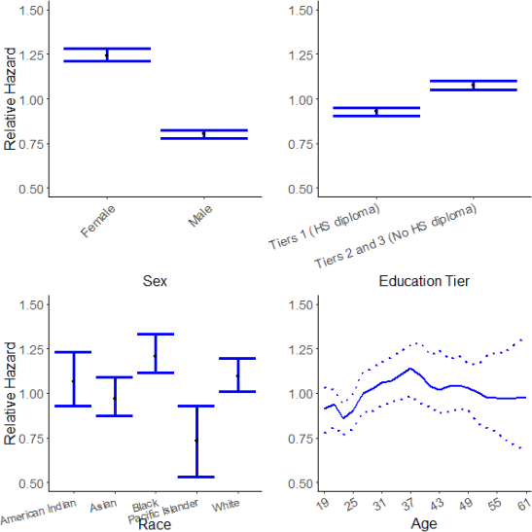
Figure 6: Fitted relative hazard rate for gender, race, education tier, and age. Education tier is a factor derived from EDU LVL CD; EDU LVL CD ≥ 31 are high school graduates (Tier 1); others are Tiers 2 and 3 (high school equivalency, non-high school graduates).

The fitted effect of advancement in rank during the first term on attrition is given by Figure 7. This is by far the strongest observed effect – Privates are over 10 times more likely to attrit than the average Soldier during their first term. We can consider rank to be a crude version of years of service, where most attrition happens early before promotion. After controlling for this, the effect of years of service in Figure 8 is periodic. We see peaks roughly 6 months before common contract end dates (3, 4, and 5 years). At the end dates themselves we see valleys where Soldiers choose to

finish out their term rather than attrit. Soldiers in a combat MOS are slightly more likely to attrit than non-combat MOS, and there is also a weak seasonal effect by calendar year.
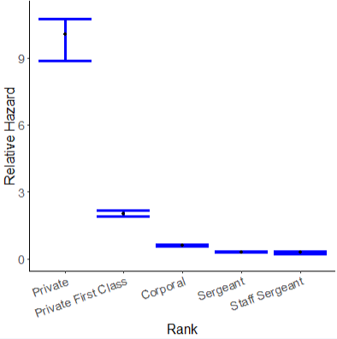
Figure 7: Fitted relative hazard rate for rank.

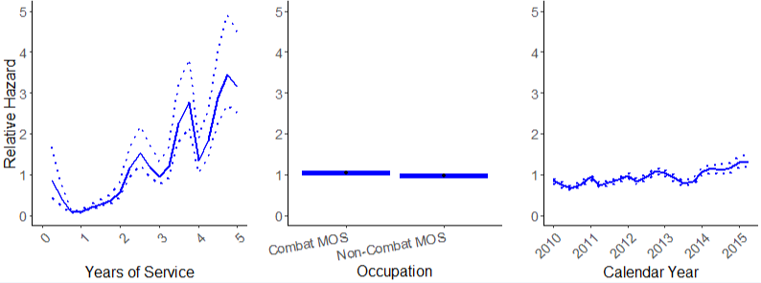

Figure 8: Fitted relative hazard rate for years of active service, calendar year, and MOS.

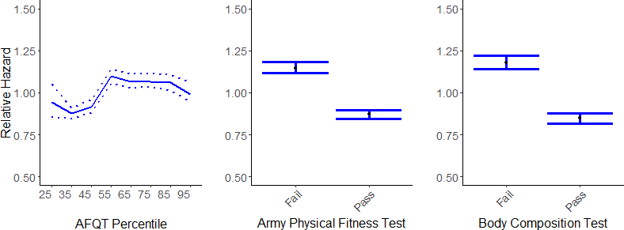

Figure 9: Fitted relative hazard rate for percentile on the Armed Forces Qualification Test, and performance on the periodic Army Physical Fitness Test and body composition test.

The effect of testing on attrition is plotted in Figure 9. Failing an APFT or body composition test in the last 3 months leads to an increased rate of attrition. Armed Forces Qualification Test

percentile has a weak effect, but surprisingly for low scores below the 55th percentile the likelihood of attrition actually decreases.
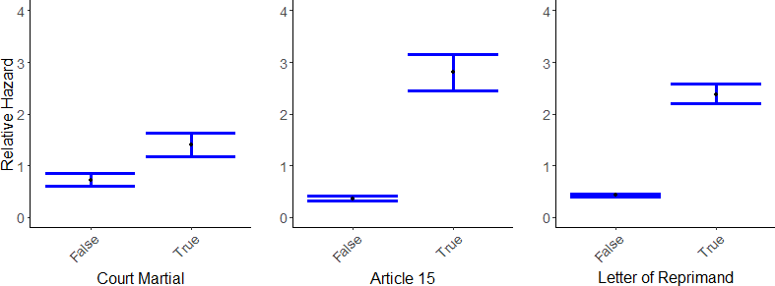

Figure 10: Fitted relative hazard rate for Courts Martial, Article 15 proceedings, and Letters of Reprimand.

The effect of punishments on attrition is given in Figure 10. These include variables for Courts Martial, Article 15 proceedings, and letters of reprimand from a superior officer. These are binary covariates that are defined as ’True’ if a Soldier received the given punishment within the last 3 month period of observation and ’False’ otherwise. We see that each of these punishments contributes to a significantly higher risk of Soldier attrition.
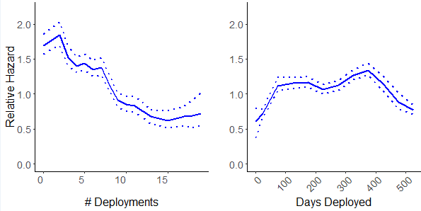
Figure 11: Fitted relative hazard rate for the number of times, and cumulative number of days a Soldier has been deployed.

The estimated effect of deployments on Soldier attrition is given in Figure 11, including the number of times and the cumulative number of days a Soldier has been deployed. A deployment occurs when a Soldier is physically located in a combat zone or area of operations. We examine deployment events tracked since 2001 in support of the Overseas Contingency Operations Operation Iraqi Freedom (OIF), Operation Enduring Freedom (OEF), and Operation New Dawn (OND).

Unit Effects
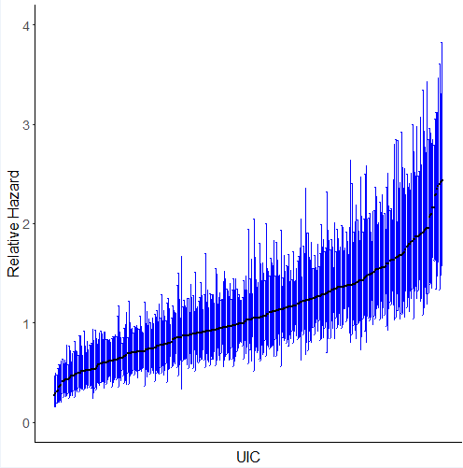
Figure 12: Fitted relative hazard rate for the unit to which a Soldier currently belongs.

A random effect is added for the unit a Soldier belongs to at the time each observation is recorded. The unit of a Soldier at a given time is determined down to the company level using the Unit Identification Code (UIC). Figure 12 plots the estimated relative hazard for each unit. There is a measurable difference in the likelihood of attrition by unit. We see that compared to units with the lowest risk, Soldiers in the units with the highest risk are up to 4 times more likely to attrit in their first term.
The effect of community factors on attrition is given in Figure 13. These factors come from the American Community Survey and Bureau of Labor Statistics Quarterly Census of Earnings and Wages, and profile the community around the base where a Soldier is currently stationed. Two of these effects have a notable effects. The percent of people in the surrounding community who receive food stamps or Supplemental Nutrition Assistance Program (SNAP) benefits. A higher percent on SNAP is associated with a higher likelihood of Soldier attrition; these bases tend to be in lower income areas. The second effect is the percent of population who are veterans. Soldiers in areas with a large veteran population tend to see lower than average attrition rates.

Baseline Model

We fit a Cox Proportional Hazards model to predict attrition outcomes for the n = 713, 037 Soldiers that are fit in the Bayesian model above. The outcome is again the binary definition of whether or not a Soldier’s contract was fulfilled. The hazard function for Soldier i at time t is defined as

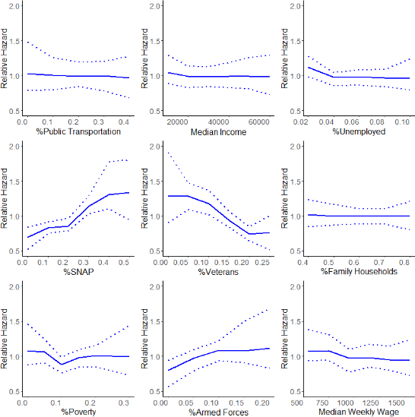

Figure 13: Fitted relative hazard rate for effects of the community surrounding the duty location of a Soldier.
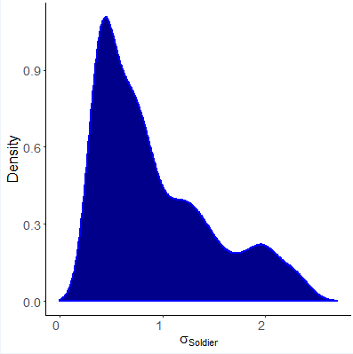

Figure 14: Posterior density estimate for the standard deviation σ1, corresponding to the random effect for Soldiers.

λ_{i}(t) = λ₀(t)exp(X_{i}β) (6)

Where X_{i} is the vector of covariates listed in Table 3. The partial likelihood of observing an attrition for Soldier i is given by

exp(X_{i}β)

PL_{i}(β) =
j
exp(X_{j}
(7)
β)

Unlike the baseline model, the model matrix for the Cox model includes no time-varying covari- ates. This means that the quarterly observations for each Soldier that were used to fit the Bayesian model are reduced to a single observation per Soldier. Covariates that were observed quarterly such as age, MOS, rank, days and number of deployments are each taken to be a single value at one time point defined to be either (a) the time the Soldier attrits, or (b) the time a Soldier has satisfied the contract of their first term of service. Covariates such as whether or not a Soldier has failed their Army Physical Fitness Test are now a single binary observation instead of multiple quarterly observations; we say a soldier has failed the APFT if they failed it at least once over their entire first term of service. Similar definitions are used to define the covariates for Body Composition Test, and results of a Court Martial, Article 15 Proceedings, and Letter of Reprimand. Data external to the DoD that vary over time with a Soldier’s duty location from the American Community Survey and Bureau of Labor Statistics are not included in the baseline model.
Unit effects and random individual effects are not included in the baseline model. These are both difficult to include in this basic model since they change over time. Random effects are difficult to specify without the Bayes formulation.
The results of this model are given in Table 3. With this large number of observations we see again that each of the fitted effects are statistically significant with the exception of score percentile on the Armed Forces Qualification Test. The strongest effects in the fitted model include length of service, rank at the time of attrition, courts martial, and article 15 proceedings. Effects such as age and cumulative days deployed have much weaker effects with coefficients close to 1.
The inclusion of time-varying covariates and external data in the Bayesian model improves the model’s ability to predict first term attrition outcomes when compared to the baseline Cox model. We compare models in terms of deviance, d = j (pˆ_{j} − p_{j})² where p_{j} is 1 if Soldier j attrits and

0 otherwise, and pˆ_{j} is the probability of attrition over the first term predicted by the model. The
baseline model as a total deviance of 97, 947 while the Bayesian model has a deviance of 64, 439, an improvement of 52%.

Table 3: Table of fitted covariates for the baseline Cox Proportional Hazards model. Estimates and 95% confidence intervals are reported. Coefficients have a statistically significant impact on the attrition hazard when the confidence interval excludes 1.

Variable | exp(Coefficient) | 95% Confidence Interval
Sex (Male) | 0.82 | (0.82, 0.83)
Education (Tier 1) | 1.04 | (1.03, 1.05)
Age | 1.01 | (1.00, 1.01)
Race (Asian) | 0.85 | (0.81, 0.89)
Race (Black) | 0.95 | (0.91, 0.99)
Race (Pacific Islander) | 0.65 | (0.59, 0.72)
Race (White) | 1.01 | (0.97, 1.05)
MOS (combat) | 0.92 | (0.91, 0.93)
Married | 1.07 | (1.06, 1.08)
Rank (Private First Class) | 0.74 | (0.73, 0.75)
Rank (Corporal) | 0.52 | (0.51, 0.53)
Rank (Sergeant) | 0.33 | (0.32, 0.34)
Rank (Staff Sergeant) | 0.26 | (0.23, 0.29)
AFQT score percentile | 1.00 | (0.99, 1.01)
Number of deployments | 0.95 | (0.94, 0.95)
Days deployed | 1.00 | (1.00, 1.00)
Army Physical Fitness Test (Failed) | 0.98 | (0.88, 0.91)
Body Composition Test (Failed) | 1.17 | (1.15, 1.20)
Court Martial | 1.60 | (1.51, 1.69)
Article 15 Proceedings | 1.50 | (1.39, 1.61)
Letter of Reprimand | 1.27 | (1.22, 1.32)
Length of Service | 0.33 | (0.32, 0.33)

Discussion

This initial project has laid important groundwork for understanding soldier behavior by amassing a vast collection of DoD and open data sources covering a 15 year period (2001-2015). In addition, this effort has also been instrumental in developing a Bayesian analysis approach suitable for leveraging this volume and variety of data to shed new light on a long-studied problem: attrition.
The effort required to put this in place was substantial. It required searching out new data sources and coordinating with the Army Analytics Group’s Research Facilitation Lab to streamline numerous processes (e.g. accessing the person data environment (PDE), ingesting new data into the PDE, approval processes, adding software). See Appendix A of this paper for more detail.
The attrition modeling and analysis based on these amassed data sources has proven to be effective. The work points to how such data sources (and accompanying statistical analyses) can provide insight over long time horizons that compliment findings traditionally derived from survey- based analysis.

Future Analyses and Potential Applications
The initial success of this effort points to opportunities to push the modeling results beyond this initial case-study on attrition. Exactly what is possible depends on what data may become available in the future. Here we consider analyses that could be carried out with the existing data available in the PDE, and analyses that would require either higher quality versions of the current data, or additional data sources.
Using the currently available data, potential directions to extend this work include:

    - assessing the impact of MOS on attrition;
    - extending the model to handle attrition events beyond the initial enlistment term of the Soldier; and
    - considering what factors affect a Soldier’s decision to reenlist or not at the end of the enlist- ment term.
Such efforts will likely provide a richer understanding of what factors affect attrition and a Soldiers decision to reenlist in the Army. In particular, there may be individual “career trajectories” that are associated with positive and negative attrition/reenlistment outcomes.
Moving beyond attrition as an outcome, it would likely be possible to identify more meaningful outcomes regarding a Soldier’s career success. Such a success scale might include measures of skill growth, promotion and advancement, or completion of tasks or missions that are deemed important to the Army. Such a success score could then be analyzed using a statistical approach similar to what was developed on this project. With such an approach there is opportunity to identify training and experience that is common to more successful Soldiers. Analysis methods recently developed to

assess the impact of individual athletes on profession sports teams might find relevance and utility in addressing the effectiveness of individual Soldiers.

Using Higher Resolution Individual Data

More broadly, the concept of combining very detailed individual transaction data with available data sources has the potential to provide insights at the individual and group levels.
Currently, only broad, county-level economic indicators and crude well-being measures (e.g. Army Physical Fitness Test score) are available in the current data sources. More detailed insight to an individual Soldier’s choices regarding attrition or reenlistment could very well be a function of his/her personal situation regarding health, finances, social life, etc. There is a potential wealth of individualized information that could better inform such studies. This might include electronic transactions, data from health apps or wearables, registration data from recreational sports leagues, etc. While the details of obtaining such data could be obtained is not obvious, such data does exist, and would certainly give an individualized picture of important factors regarding Soldier satisfaction.

Improved Understanding of Group Dynamics

A second thrust of future analyses could focus on team/group effects, as well as effects asso- ciated with team/group leadership. This research has not made a concerted effort to detail squad/team/unit grouping for each Soldier at each timepoint, nor has it identified leaders of these different groupings. While it is not clear such resolution exists in the currently available data source, data detailing group associations could provide insight on a number of interesting questions. For example
      - Do we see dependence within groupings regarding attrition or reenlistment decisions? If so, which groupings?
      - To what degree is the attrition rate within a group associated with the attributes of the individual Soldiers that make up the group?
      - To what degree is the attrition rate within a group associated with the leader of that group?

Such investigations will need reliable information regarding the networks and groupings of individual soldiers, and will also need accurate information regarding leadership of these groupings.

References
Abelson, M. A. and Baysinger, B. D. (1984). Optimal and dysfunctional turnover: Toward an organizational level model. Academy of management Review, 9(2):331–341.

Adams, C. J., Hough, H., Proeschold-Bell, R. J., Yao, J., and Kolkin, M. (2017). Clergy burnout: A comparison study with other helping professions. Pastoral Psychology, 66(2):147–175.
Allen, D. (1999). Desire to finish college: An empirical link between motivation and persistence.
Research in higher education, 40(4):461–485.
Allen, D. G., Weeks, K. P., and Moffitt, K. R. (2005). Turnover intentions and voluntary turnover: the moderating roles of self-monitoring, locus of control, proactive personality, and risk aversion. Journal of Applied Psychology, 90(5):980.
Allensworth, E. M. and Easton, J. Q. (2005). The On-Track Indicator as a Predictor of High School Graduation. Consortium on Chicago School Research, University of Chicago.
Asch, B. J., Heaton, P., Hosek, J., Martorell, F., Simon, C., and Warner, J. T. (2010). Cash incen- tives and military enlistment, attrition, and reenlistment. Technical report, RAND NATIONAL DEFENSE RESEARCH INST SANTA MONICA CA.
Asch, B. J., Mattock, M. G., and Hosek, J. (2013). A New Tool for Assessing Workforce Manage- ment Policies Over Time. Rand Corporation.
Asch, B. J., Romley, J. A., and Totten, M. E. (2005). The quality of personnel in the enlisted ranks. Technical report, DTIC Document.
Bauer, T. N., Erdogan, B., Liden, R. C., and Wayne, S. J. (2006). A longitudinal study of the moderating role of extraversion: Leader-member exchange, performance, and turnover during new executive development. Journal of Applied Psychology, 91(2):298.
Bean, J. P. (1985). Interaction effects based on class level in an explanatory model of college student dropout syndrome. American educational research journal, 22(1):35–64.
Bentein, K., Vandenberghe, C., Vandenberg, R., and Stinglhamber, F. (2005). The role of change in the relationship between commitment and turnover: a latent growth modeling approach. Journal of Applied Psychology, 90(3):468.
Bergiel, E., Nguyen, V., Taylor, G., and Clenney, B. (2014). Human resource practices, job em- beddedness, and voluntary turnover.
Besag, J., Green, P., Higdon, D., and Mengersen, K. (1995). Bayesian computation and stochastic systems. Statistical Science, pages 3–41.
Borman, G. D. and Dowling, N. M. (2008). Teacher attrition and retention: A meta-analytic and narrative review of the research. Review of educational research, 78(3):367–409.
Brooks, S., Gelman, A., Jones, G., and Meng, X.-L. (2011). Handbook of Markov Chain Monte Carlo. CRC press.
Buddin, R. (1988). Trends in attrition of high-quality military recruits. Technical report, RAND CORP SANTA MONICA CA.
Buddin, R. J. (2005). Success of first-term soldiers. the effects of recruiting practices and recruit characteristics. Technical report, DTIC Document.

Burkhauser, S., Hanser, L. M., and Hardison, C. M. (2014). Elements of success: How type of sec- ondary education credential helps predict enlistee attrition. Technical report, RAND NATIONAL DEFENSE RESEARCH INST SANTA MONICA CA.
Cabrera, A. F., Nora, A., and Castaneda, M. B. (1993). College persistence: Structural equations modeling test of an integrated model of student retention. Journal of Higher Education, pages 123–139.
Casella, G. and Berger, R. L. (2002). Statistical inference, volume 2. Duxbury Pacific Grove, CA.
Cotton, J. L. and Tuttle, J. M. (1986). Employee turnover: A meta-analysis and review with implications for research. Academy of Management Review, 11(1):55–70.
Council, N. R. et al. (2011). High school dropout, graduation, and completion rates: Better data, better measures, better decisions. National Academies Press.
Cox, D. R. (1972). Regression models and life-tables (with discussions). Journal of the Royal Statistical Society (Series B), 34:187–220.
Croan, G. M., Bowen, G. L., Farkas, G., Glickman, A., Orthner, D., Nogami, G. Y., Gade, P. A., and Tremble Jr, T. R. (1990). Career decision-making and the military family: Toward a com- prehensive model. Technical report, DTIC Document.
Davis, P. R., Trevor, C. O., and Feng, J. (2015). Creating a more quit-friendly national workforce? individual layoff history and voluntary turnover. Journal of Applied Psychology, 100(5):1434.
DoD (2012). Report of the eleventh quadrennial review of military compensation. Technical report, Department of Defense, Main Report. 1417, RefID: 3-80904F8.
Dup´er´e, V., Leventhal, T., Dion, E., Crosnoe, R., Archambault, I., and Janosz, M. (2015). Stressors and turning points in high school and dropout: A stress process, life course framework. Review of Educational Research, 85(4):591–629.
Ellingson, J. E., Tews, M. J., and Dachner, A. M. (2016). Constituent attachment and voluntary turnover in low-wage/low-skill service work. Journal of Applied Psychology, 101(1):129.
Englert, D. R., Hunter, C. L., and Sweeney, B. J. (2003). Mental health evaluations of us air force basic military training and technical training students. Military medicine, 168(11):904–910.
Flores, M. A. and Day, C. (2006). Contexts which shape and reshape new teachers’ identities: A multi-perspective study. Teaching and teacher education, 22(2):219–232.
Freudenberger, H. J. (1975). The staff burn-out syndrome in alternative institutions. Psychotherapy: Theory, Research & Practice, 12(1):73.
Garcia, S. M., Ortman, B. V., and Burnett, D. G. (2015). Mental health diagnoses and attrition in air force recruits. Military medicine, 180(4):436–444.
Gibson, J. L., Hackenbracht, J., and Tremble, T. R. (2014). An event history analysis of first-term soldier attrition. Military Psychology, 26(1):55.

Gilks, W. R., Richardson, S., and Spiegelhalter, D. (1995). Markov chain Monte Carlo in practice.
CRC press.
Hawkins, S. A., Sullivan, K. S., Schuyler, A. C., Keeling, M., Kintzle, S., Lester, P. B., and Castro,
C. A. (2017). Thinking big about research on military families. Military Behavioral Health, 5(4):335–345.
Hesford, J. W., Malina, M. A., and Pizzini, M. (2016). Turnover and unit-level financial perfor- mance: An analysis of the costs and benefits of voluntary and involuntary turnover in unskilled jobs. In Advances in Management Accounting, pages 35–65. Emerald Group Publishing Limited.
Hoge, C. W., Auchterlonie, J. L., and Milliken, C. S. (2006). Mental health problems, use of mental health services, and attrition from military service after returning from deployment to iraq or afghanistan. Jama, 295(9):1023–1032.
Hoge, C. W., Lesikar, S. E., Guevara, R., Lange, J., Brundage, J. F., Engel Jr, C. C., Messer,
S. C., and Orman, D. T. (2002). Mental disorders among us military personnel in the 1990s: association with high levels of health care utilization and early military attrition. American Journal of Psychiatry, 159(9):1576–1583.
Holtom, B. C. and Inderrieden, E. J. (2006). Integrating the unfolding model and job embeddedness model to better understand voluntary turnover. Journal of Managerial Issues, pages 435–452.
Holtom, B. C., Mitchell, T. R., Lee, T. W., and Eberly, M. B. (2008). 5 turnover and retention research: a glance at the past, a closer review of the present, and a venture into the future. The Academy of Management Annals, 2(1).
Holtom, B. C., Mitchell, T. R., Lee, T. W., and Inderrieden, E. J. (2005). Shocks as causes of turnover: What they are and how organizations can manage them. Human Resource Manage- ment: Published in Cooperation with the School of Business Administration, The University of Michigan and in alliance with the Society of Human Resources Management, 44(3):337–352.
Holtom, B. C., Tidd, S. T., Mitchell, T. R., and Lee, T. W. (2013). A demonstration of the importance of temporal considerations in the prediction of newcomer turnover. Human Relations, 66(10):1337–1352.
Ibrahim, J. G., Chen, M.-H., and Sinha, D. (2005). Bayesian Survival Analysis. Wiley Online Library.
Jennings, E. and Babin, N. (2007). Annotated bibliography: Research on enlisted attrition in the us army. Technical report, DTIC Document.
Jiang, K., Liu, D., McKay, P. F., Lee, T. W., and Mitchell, T. R. (2012). When and how is job embeddedness predictive of turnover? a meta-analytic investigation. Journal of Applied Psychology, 97(5):1077.
Kammeyer-Mueller, J. D., Wanberg, C. R., Glomb, T. M., and Ahlburg, D. (2005). The role of temporal shifts in turnover processes: it’s about time. Journal of Applied Psychology, 90(4):644.
Keating, E. G., Massey, H. G., Mele, J. D., and Mundell, B. F. (2010). An analysis of the populations of the air force’s medical and professional officer corps. Technical report, DTIC Document.

Keller, S., Korkmaz, G., Orr, M., Schroeder, A., and Shipp, S. (2017). The evolution of data quality: Understanding the transdisciplinary origins of data quality concepts and approaches.
King, A. J. (2014). Bayesian event history analysis with applications to recurrent episodes of illicit drug use. Ph.D. Thesis, Department of Biostatistics, University of California Los Angeles.
King, A. J. (2017). brea: Bayesian Recurrent Event Analysis. R package version 0.2.0.
Knapik, J. J., Jones, B. H., Hauret, K., Darakjy, S., and Piskator, E. (2004). A review of the literature on attrition from the military services: Risk factors for attrition and strategies to reduce attrition. Technical report, DTIC Document.
Kubisiak, U. C., Lentz, E., Horgen, K. E., Bryant, R. H., Connell, P. W., Tuttle, M. D., Borman,
W. C., Young, M. C., and Morath, R. (2009). Review of interventions for reducing enlisted attrition in the us military: An update. Technical report, DTIC Document.
Kuh, G. D., Kinzie, J., Buckley, J. A., Bridges, B. K., and Hayek, J. C. (2006). What matters to student success: A review of the literature. In Commissioned report for the national symposium on postsecondary student success: Spearheading a dialog on student success.
Larson, G. E., Highfill-McRoy, R. M., and Booth-Kewley, S. (2008). Psychiatric diagnoses in historic and contemporary military cohorts: Combat deployment and the healthy warrior effect. American Journal of Epidemiology, 167(11):1269–1276.
Laurence, J. H., Naughton, J., and Harris, D. A. (1996). Attrition revisited: Identifying the problem and its solutions. Technical report, DTIC Document.
Lee, T. W. and Mitchell, T. R. (1994). An alternative approach: The unfolding model of voluntary employee turnover. Academy of Management Review, 19(1):51–89.
Lee, T. W., Mitchell, T. R., Holtom, B. C., McDaneil, L. S., and Hill, J. W. (1999). The unfolding model of voluntary turnover: A replication and extension. Academy of Management journal, 42(4):450–462.
Lee, T. W., Mitchell, T. R., Sablynski, C. J., Burton, J. P., and Holtom, B. C. (2004). The effects of job embeddedness on organizational citizenship, job performance, volitional absences, and voluntary turnover. Academy of Management Journal, 47(5):711–722.
Liu, D., Mitchell, T. R., Lee, T. W., Holtom, B. C., and Hinkin, T. R. (2012). When employees are out of step with coworkers: How job satisfaction trajectory and dispersion influence individual- and unit-level voluntary turnover. Academy of Management Journal, 55(6):1360–1380.
Maertz Jr, C. P. and Campion, M. A. (2004). Profiles in quitting: Integrating process and content turnover theory. Academy of Management Journal, 47(4):566–582.
Mallol, C. M., Holtom, B. C., and Lee, T. W. (2007). Job embeddedness in a culturally diverse environment. Journal of Business and Psychology, 22(1):35–44.
Manacapilli, T., Matthies, C. F., Miller, L. W., Howe, P., Perez, P., Hardison, C. M., Massey,
H. G., Greenberg, J., Beighley, C., and Sims, C. S. (2012). Reducing attrition in selected air force training pipelines. Technical report, DTIC Document.

Maslach, C. (1998). A multidimensional theory of burnout. Theories of organizational stress, 68. Maslach, C. (2003). Burnout: The cost of caring. Ishk.
Maslach, C., Schaufeli, W. B., and Leiter, M. P. (2001). Job burnout. Annual review of psychology, 52(1):397–422.
Mattock, M. G. and Arkes, J. (2007). The Dynamic Retention Model for Air Force Officers: New Estimates and Policy Simulations of the Aviator Continuation Pay Program, volume 470. Rand Corporation.
McCullagh, P. and Nelder, J. A. (1989). Generalized Linear Models, volume 37. CRC Press.
Mitchell, T. R., Holtom, B. C., Lee, T. W., Sablynski, C. J., and Erez, M. (2001). Why people stay: Using job embeddedness to predict voluntary turnover. Academy of management journal, 44(6):1102–1121.
Mitchell, T. R. and Lee, T. W. (2001). The unfolding model of voluntary turnover and job em- beddedness: Foundations for a comprehensive theory of attachment. Research in organizational behavior, 23:189–246.
Morrell, K., Loan-Clarke, J., and Wilkinson, A. (2001). Unweaving leaving: The use of models in the management of employee turnover. International Journal of Management Reviews, 3(3):219– 244.
Mossholder, K. W., Settoon, R. P., and Henagan, S. C. (2005). A relational perspective on turnover: Examining structural, attitudinal, and behavioral predictors. Academy of Management Journal, 48(4):607–618.
Niebuhr, D. W., Gubata, M. E., Oetting, A. A., Weber, N. S., Feng, X., and Cowan, D. N. (2013). Personality assessment questionnaire as a pre-accession screen for risk of mental disorders and early attrition in us army recruits. Psychological services, 10(4):378.
Niebuhr, D. W., Scott, C. T., Li, Y., Bedno, S. A., Han, W., and Powers, T. E. (2009). Preaccession fitness and body composition as predictors of attrition in us army recruits. Military medicine, 174(7):695–701.
Niebuhr, D. W., Scott, C. T., Powers, T. E., Li, Y., Han, W., Millikan, A. M., and Krauss,
M. R. (2008). Assessment of recruit motivation and strength study: preaccession physical fitness assessment predicts early attrition. Military Medicine, 173(6):555–562.
Panaccio, A., Vandenberghe, C., and Ben Ayed, A. K. (2014). The role of negative affectivity in the relationships between pay satisfaction, affective and continuance commitment and voluntary turnover: A moderated mediation model. Human relations, 67(7):821–848.
Peltokorpi, V., Allen, D. G., and Froese, F. (2015). Organizational embeddedness, turnover inten- tions, and voluntary turnover: The moderating effects of employee demographic characteristics and value orientations. Journal of Organizational Behavior, 36(2):292–312.

Podsakoff, N. P., LePine, J. A., and LePine, M. A. (2007). Differential challenge stressor-hindrance stressor relationships with job attitudes, turnover intentions, turnover, and withdrawal behavior: a meta-analysis. Journal of applied psychology, 92(2):438.
Purba, D. E., Oostrom, J. K., Born, M. P., and van der Molen, H. T. (2016). The relationships between trust in supervisor, turnover intentions, and voluntary turnover: Testing the mediating effect of on-the-job embeddedness. Journal of Personnel Psychology, 15(4):174.
Rafferty, A. E. and Griffin, M. A. (2006). Perceptions of organizational change: A stress and coping perspective. Journal of applied psychology, 91(5):1154.
Regional Educational Laboratory (2011). Indicators of success/dropout k–12. Technical report, Regional Educational Laboratory, The University of North Carolina at Greensboro.
Rumberger, R. W. and Lim, S. A. (2008). Why students drop out of school: A review of 25 years of research. Technical report, California Dropout Research Project Report.
Sanchez, R. P., Bray, R. M., Vincus, A. A., and Bann, C. M. (2004). Predictors of job satisfaction among active duty and reserve/guard personnel in the us military. Military Psychology, 16(1):19– 35.
Schaefer, L., Long, J. S., and Clandinin, D. J. (2012). Questioning the research on early career teacher attrition and retention. Alberta Journal of Educational Research, 58(1).
Schaufeli, W. B., Leiter, M. P., and Maslach, C. (2009). Burnout: 35 years of research and practice.
Career development international, 14(3):204–220.
Schmidt, J. A., Willness, C. R., Jones, D. A., and Bourdage, J. S. (2018). Human resource management practices and voluntary turnover: A study of internal workforce and external labor market contingencies. The International Journal of Human Resource Management, 29(3):571– 594.
Schneider, R. J., Johnson, J. W., Cochran, C. C., Hezlett, S. A., Foldes, H. J., and Ervin, K. S. (2011). Development and evaluation of a career continuance model for company grade officers in the united states army. Technical report, DTIC Document.
Segrest, S. L., Andrews, M. C., and Hurley-Hanson, A. E. (2015). Voluntary turnover typology utilizing the dispositional variables of core self-evaluation and negative affectivity. Journal of Behavioral Studies in Business, 8:1.
Selden, S. C. and Sowa, J. E. (2015). Voluntary turnover in nonprofit human service organizations: The impact of high performance work practices. Human Service Organizations: Management, Leadership & Governance, 39(3):182–207.
Shaw, J. D., Duffy, M. K., Johnson, J. L., and Lockhart, D. E. (2005a). Turnover, social capital losses, and performance. Academy of Management Journal, 48(4):594–606.
Shaw, J. D., Gupta, N., and Delery, J. E. (2005b). Alternative conceptualizations of the relationship between voluntary turnover and organizational performance. Academy of management journal, 48(1):50–68.

Shipp, S., Lancaster, V., Keller, S., Pires, B., Molfino, E., Ziemer, K., Orr, M., Higdon, D., Goldstein, J., Korkmaz, G., and Schroeder, A. (2016). Attrition and retention - a review across selected disciplines. deliverable to us. army research institute. Technical report, Social Decision Analytics Laboratory, Bicomplexity Institute of Virginia Tech.
Shirom, A. (2011). Job-related burnout: A review of major research foci and challenges.
Spell, H. B., Eby, L. T., and Vandenberg, R. J. (2014). Developmental climate: A cross-level analysis of voluntary turnover and job performance. Journal of vocational behavior, 84(3):283– 292.
Stearns, E. (2011). High school dropouts. In Encyclopedia of Adolescence, pages 1303–1308.
Springer.
Steel, R. P. (2002). Turnover theory at the empirical interface: Problems of fit and function.
Academy of Management Review, 27(3):346–360.
Sticha, P. J., Dall, T. A., Handy, K., Espinosa, J., and Hogan, P. F. (2003). Impact of the army continuing education system (aces) on soldier retention and performance: Data analyses. Technical report, DTIC Document.
Strickland, W. J. (2005). A longitudinal examination of first term attrition and reenlistment among fy1999 enlisted accessions. Technical report, DTIC Document.
Sturman, M. C. and Trevor, C. O. (2001). The implications of linking the dynamic performance and turnover literatures. Journal of Applied Psychology, 86(4):684.
Vie, L. L., Griffith, K. N., Scheier, L. M., Lester, P. B., and Seligman, M. E. (2013). The person- event data environment: leveraging big data for studies of psychological strengths in soldiers. Frontiers in psychology, 4:934.
Vie, L. L., Scheier, L. M., Lester, P. B., Ho, T. E., Labarthe, D. R., and Seligman, M. E. (2015). The us army person-event data environment: a military–civilian big data enterprise. Big data, 3(2):67–79.
Wanberg, C. R. and Banas, J. T. (2000). Predictors and outcomes of openness to changes in a reorganizing workplace. Journal of applied psychology, 85(1):132.
Weinberg, S., Edwards, G., and Garove, W. (1983). Burnout among employees of state residen- tial facilities serving developmentally disabled persons. Children and Youth Services Review, 5(6):239–253.
Weiss, H. M., MacDermid, S. M., Strauss, R., Kurek, K. E., Le, B., and Robbins, D. (2003). Retention in the armed forces: Past approaches and new research directions. Military Family Research Institute, Purdue University.
Weller, I., Holtom, B. C., Matiaske, W., and Mellewigt, T. (2009). Level and time effects of recruitment sources on early voluntary turnover. Journal of Applied Psychology, 94(5):1146.
Wilcox, V. L. (2000). Burnout in military personnel. Military Psychiatry: Preparing in Peace for War, pages 31–50.

Wilson, A. L. G., Messer, S. C., and Hoge, C. W. (2009). Us military mental health care utiliza- tion and attrition prior to the wars in iraq and afghanistan. Social psychiatry and psychiatric epidemiology, 44(6):473–481.
Wolfe, J., Turner, K., Caulfield, M., Newton, T. L., Melia, K., Martin, J., and Goldstein, J. (2005). Gender and trauma as predictors of military attrition: A study of marine corps recruits. Military Medicine, 170(12):1037–1043.

Appendix

Accessing and Using the Person-event Data Environment

Overview
The Person-event Data Environment (PDE) is a business intelligence platform in a cloud-based virtual data repository for housing data from the DOD and each of the military services (Vie et al., 2013, 2015). The PDE was established in 2006 by the U.S. Department of Defense and is managed by the Department of the Army to facilitate research and analysis of issues and policies that affect the military workforce and their families (Hawkins et al., 2017). The PDE provides a repository for manpower, service, personnel, financial, behavioral health, and medical data that that researchers can access remotely through a secure online process. In the PDE, a wide range of person-related data can be accumulated, quality-controlled, de-identified to protect privacy information, shared, and utilized for operational support and research. Using strong security protocols, the PDE encodes personally-identifiable information (PII), thereby providing an integrated solution to significantly enhance access to manpower, personnel, and medical data (Hawkins et al., 2017).
The PDE Data Enclave is run by the Army Analytics Groups (AAG) Research Facilitation Laboratory (RFL) in Monterey, California. We meet biweekly with the RFL staff. Though these discussions, we identify and request access to data in the PDE

Gaining Access to the PDE
Access to these data in the PDE Data Enclave requires using a Common Access Card (CAC). All work is done on the PDE server. All members of the research team have a CAC and permission to conduct research in the PDE. Only aggregate results that are reviewed by PDE staff are allowed to be downloaded for use in reports and publications. Obtaining a CAC is somewhat challenging and would not be possible without the assistance of Valerie C. Rigoglioso, Management Services Officer, G1 US Army Research Institute, Research Support Unit. The length of time depends on prior clearances held by the individual and category:
    - Currently or recently had a security clearance (5 staff): 60-75 days

    - No prior security clearances (7 staff): 60-240 days

    - Foreign national (1 staff): 240 days

    - Since Fall 2017, the timing is usually about 90 days

    - New challenges have occrred since Spring 2018. The Personnel Security Investigation Portal (PSIP) system has been down for extended periods of time. This has affected the length of time for recent applications.
Access also requires getting and maintaining Institutional Review Board (IRB) and US Army Research Institute Human Resources Protection Office (HRPO) approvals. We updated the Virginia Tech IRB, the US Army Research Institute HRPO, and the Army Analytics Group agreements to facilitate access to more sensitive data. The Virginia Tech IRB approved the revised protocol on June 14, 2017, the U.S. ARI approved the HRPO on August 25, 2017, and Daniel Jensen, Director, Army Analytics Group, signed the Institutional Official Research Approval on August 28, 2017. The IRB was updated to add additional staff and was approved on March 28, 2018.
Once CACs are obtained and the IRB and HRPO approvals are received, the next step is gaining access to the PDE. The first step is completion of a mandatory one-hour training that provides an overview of the system. The RFL then sets the permission to allow individual access to the PDE. The second step is creating a user profile in the PDE and to create passwords to access Oracle. This process initially took from January through August 2016 when three staff gained access. The remaining staff gained access during the Fall of 2016. The primary challenge was using MACs instead of PCs.
Both SDAL and RFL are learning from each other in creating a useful environment for re- searchers within the PDE. RFL has implemented improvements, such as users can reset passwords in the portal and use self-help protocols for unlocking accounts; data catalogs are improved; RAM and CPU processing are increased; and better metadata and codebooks are provided. However, we still would like RFL to Implement single sign-in (not the current quadruple sign-in); to add FAQs about rules for batch job submissions; to balance load across desktops; to move computational servers from Windows to Redhat Linux when possible; to install SPARK with HADOOP backend; and to install Python.

The process of adding data sources to the PDE
SDAL works with the AAG RFL to identify and access data in the PDE. There are four types of requests:
- Data are in the PDE and we can request access to the data directly. We request access by selecting the files and variables in the PDE using a system that allows the user to check the

desired files and variables. Examples of these files include the Active Duty Master file, Active Duty Transaction file, Analyst file, and the Military Awards file.
- Data are in the PDE and we must receive the data sponsors approval to access the data. We are required to submit a description of the overall project and the rationale for wanting access to the data. Examples of these data sources include access to the Pre-During-Post Deployment Health files, the Defense Equal Opportunity Management Institute (DEOMI) Organizational Climate Survey (DEOCS), Soldier for Life, Millennium Cohort Survey (MilCo), and Tailored Adaptive Personality Assessment System (TAPAS). In some cases, the sponsor allows access to the data but not the demographics, greatly reducing the usefulness of the data. Examples include the Soldier for Life and DEOMI information.
- Data are not in the PDE, requiring research and identification of the sponsor and person who can give permission to access and use the data in the PDE. Some data sources are discovered through the literature. A current example includes the Ethical Climate Assessment Survey (ECAS), from the Office of the Chaplain.
- Data are not in the PDE but are publicly available, such as data from the U.S. Census Bureau. Working with the RFL staff, we developed a procedure and uploaded American Community Survey data for every census block for 2005-2015 to be used in our research project. These data are now available to all PDE users.

Data Science Framework
For each new data source, we follow a rigorous yet flexible approach that we call our Data Science Framework (see Figure 15). Given the research question and working hypotheses, we first undertake a data discovery process to identify relevant data files both within and external to the PDE. Once the data sources are identified and permissions set to allow SDAL to access the data within the PDE, we select relevant variables for our analyses, and undertake the process of profiling, cleaning, linking, and exploring as the first step to using the data in modeling and analyses. This stage sometimes involves examining the same variables, across files. For example, we compared demographics using Master, Transaction, and Analyst files and concluded that the Master File has the most consistent demographic data. Each file has specific data that are especially valuable, for example the Transaction file is used for separation codes and the Army Analyst file for obtaining information on test scores.
Through our research, we have developed a data science framework (see Figure 15) to create methods for identifying and integrating multiple data sources to address specific research questions. Data Discovery identifies data that naturally exist, including administrative, previously de- signed data collections, opportunity, and procedural data. These data sources are likely to have

been collected for other reasons, other than the problem at hand, and require repurposing to mea- sure concepts of interest. Once discovered, the data sources are inventoried and then screened to determine which are useful to acquire for the intended research questions.
Data Ingestion and Governance involves the quality assessment of the data sources through data profiling to evaluate the representativeness, timeliness, accuracy, consistency, completeness, reliability, and relevance of the data. The ingestion process needs to capture all known metadata and provenance to help guide the profiling processes and inform the data preparation steps. The data may come from many difference sources. The governance (e.g., access and privacy) that surrounds the data needs to be captured and adhered to during the data linkage steps. Data exploration combines and explores the data to gain an understanding of the spatial and temporal biases and coverage relative to the specific research questions.
Fitness-for-Use Assessment and Statistical Modeling and Data Analyses are tightly coupled. Given a particular analysis, fitness-for-use of the associated data is a characterization of the information content in the data that can support the particular analysis. This is a function of the statistical model(s) used, the data quality needs of the model(s), and the data coverage needs of the model(s). Of note, the statistical modeling and analyses step is considered broadly in this framework and includes evaluation.
The components in the data science framework are based on scientific principles, from the engi- neering and computational fields, e.g., statistical process control, Total Data Quality Management, visualization tools, and simulation experiments. The processes represented in our framework are critical for creating defensible and repeatable measures.

Data sources added to the PDE
We identified data sources and explored their use for describing and modeling attrition. We have currently acquired the DOD/U.S. Army data files listed in Table 4. We also developed a data source map (see Figure 16) that captures the relationships between the data files and lays the ground work for how the data can be linked.

Modeling and computation within the PDE
We constructed a virtual environment within the PDE to access, profile, clean, integration, and explore the data, and then create statistical models and analyze the results (see Figure 15). We discovered, accessed, profiled, and transformed over 200 variables using three large administrative files in the PDE - Active Duty Master File, Regular Army Analyst, and Transaction File plus many other files listed in Table 4, including the Census Bureaus American Community Survey. We then created statistical models (described in the main report) and analyzed results. We used the same software tools that we use in all our SDAL research, e.g., R and RStudio. We also imported our

Problem Identification: Relevant Theories & Working Hypotheses
Data Discovery
ADMINISTRATIVE DATA, DESIGNED DATA, OPPORTUNITY DATA,
& PROCEDURAL DATA
DATA INGESTION & GOVERNANCE
Inventory, Screening & Acquisition
DATA PROFILING
Data Structure, Data Quality, Provenance & Meta Data
DATA PREPARATION
Cleaning, Transformation, Restructuring
DATA LINKAGE
Ontology, Selection & Alignment, Entity Resolution
DATA EXPLORATION
Characterization, Summarization, Visualization
FITNESS-FOR-USE-ASSESSMENT
STATISTICAL MODELING & DATA ANALYSES

Figure 15: The Social and Decision Analytics Laboratorys Data Science Framework (The data science framework development that has emerged from this research contains the following components: data discovery (finding poten- tial data sources to address the issue), data inventory (screening), data acquisition (negotiating and acquiring the data, and managing legal, privacy, security, and confidentiality practices), data profiling (determination of both the quality of the data, provenance, and its utility to the project at hand), data preparation (cleaning and readying the data for analysis), data linkage (building links to ensure compatible meaning, schemas, and ontology for data from multiple sources, resulting from the repurposing of the data), data exploration (summarizing main characteristics, often with visual methods), fitness-for-use assessment (characterizing the information content in the results as a function of the analysis model, the data quality needs of the model), and the data coverage (representativeness), and modeling and analysis (a model that embodies a set of statistical assumptions concerning the generation of some sample data and similar data from a larger population.) (Keller et al., 2017)

automated data profiling tool that reduces the time to profile data by half. See Figure 17 for an example of the output from the Data Profiling Tool.

Review of Literature on Attrition and Related Topics

This appendix presents a summary of the literature review that we delivered to ARI in December 2016 (Shipp et al., 2016). It provides a brief overview of the literature on military attrition, and insights from the non-military literature on burnout in the helping professions, (police officers, emergency management technicians, and clergy), turnover in management, and attrition ins ed-

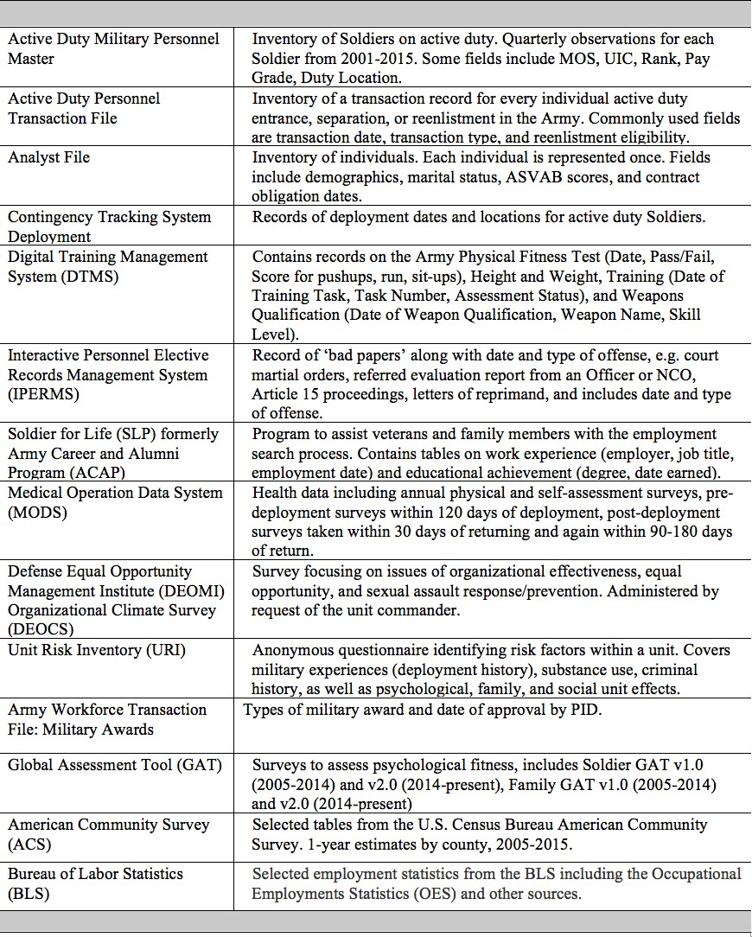

Table 4: Data Sources acquired for research to model attrition of enlisted Soldiers. Sources: Army Analytics Laboratory, Research Facilitation Laboratory, Person Data Environment, and U.S. Census Bureau

ucation ( high school and college students and teachers) These topics have synergies with Army attrition.

Military Literature on Attrition and Related Topics
The focus of our research, first-term attrition, is a separation from the military that occurs before the Soldiers first term ends that is not a reenlistment, extension, or transfer to the Officer level (Asch et al., 2005). First term attrition is a common attrition definition and focus (Asch et al., 2010, 2005; Buddin, 2005). Others base their attrition on length of service (Burkhauser et al., 2014). Attrition

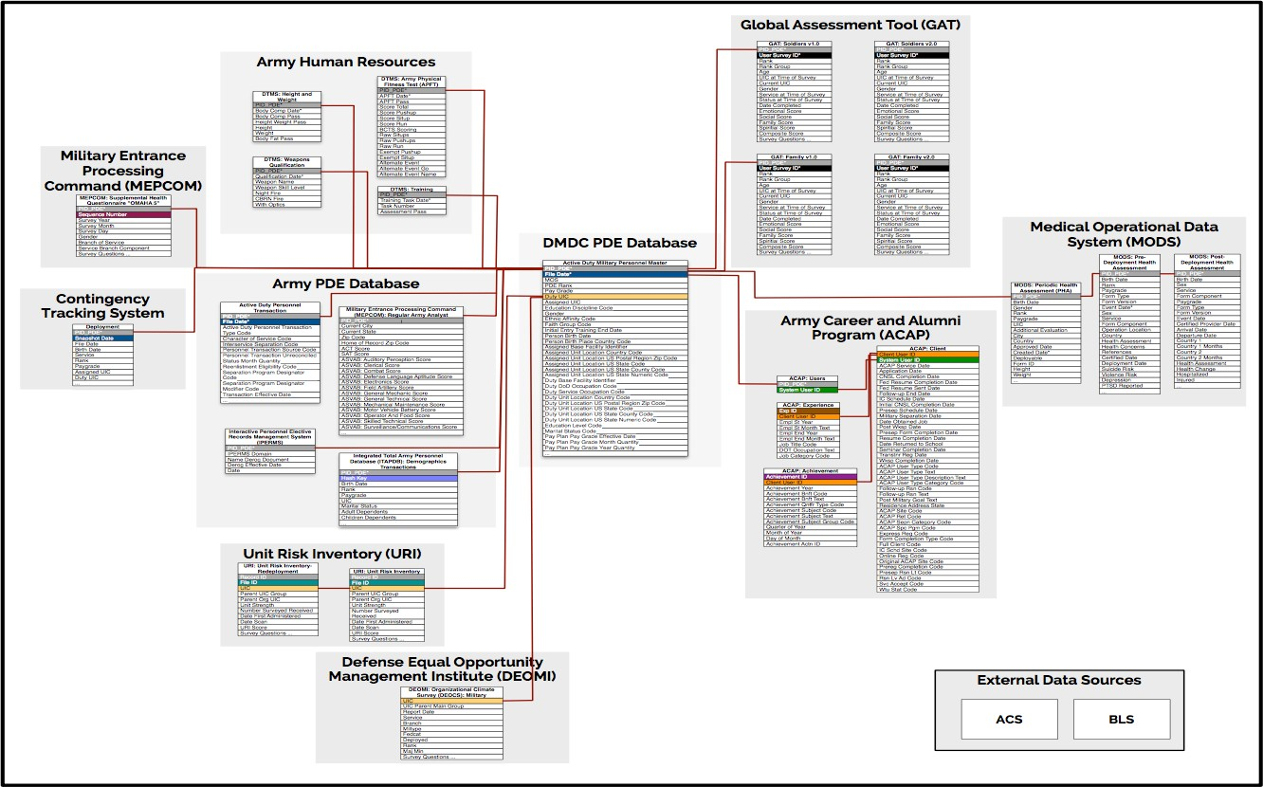

Figure 16: The Data Source Map captures the relationships between the Person Data Environment (PDE) data files and lays the ground work for how the data can be linked. The data sources include external data sources that we have ingested into the PDE, such as the Census Bureaus American Community Survey (ACS).

is also defined as involuntary separation or discharge often due to medical concerns (Niebuhr et al., 2008; Hoge et al., 2002, 2006; Wilson et al., 2009). Military attrition has been summarized in many comprehensive reviews (Croan et al., 1990; Laurence et al., 1996; Weiss et al., 2003; Sticha et al., 2003; Knapik et al., 2004; Strickland, 2005; Jennings and Babin, 2007; Kubisiak et al., 2009; Asch et al., 2010; DoD, 2012). Therefore, we are not providing a comprehensive review. What follows is a brief review of selected studies that focus on military attrition and related factors.
Recruit quality: The primary component of how the military services define recruit quality is a combination of education credentials and the Armed Forces Qualification Test (AFQT) scores, which is derived from the Armed Services Vocational Aptitude Battery (ASVAB). Using such mea- sures, the quality of recruits has increased substantially. However, this has not been shown to lead to decreased retention rates (Buddin, 1988). Research has attempted to update the opera-

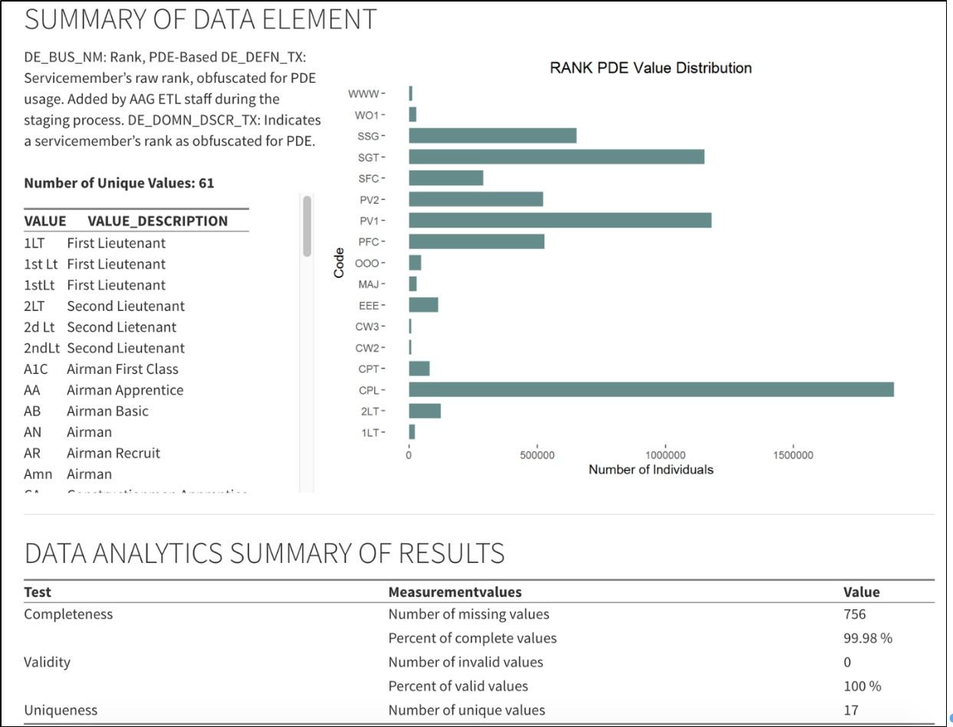

Figure 17: Data Profiling Example showing distribution of rank of Army Soldier for data in Person-event Data Environment.(Data quality for selected variables is examined through a profiling process that evaluates completeness, value validity, longitudinal consistency, and uniqueness of the data. Data profiling is partially automated using algorithms, encoded and explained in R Markdown. The outputs are HTML files that facilitate the review of the data.)

tionalization of recruit quality. Burkhauser et al. (2014), for instance, focused on recruits coming from homeschool and virtual schooling background and whether such recruits should continue to be classified as traditional high school diploma graduates, which is associated with lower risk of attrition (Burkhauser et al., 2014). Other research focused on the health of recruits in regards to weight and body fat Niebuhr et al. (2009).
Training and Premature Attrition: A significant portion of the financial costs for the military from early attrition comes from the costs associated with training that recruit. This is especially true when a new recruit fails to complete training, are forced to repeat training (washbacks), or attrit shortly after training and initial investment. Limiting such costs is important for military

policy, and thus has been a focus of many studies. Manacapilli et al. (2012) investigates enlisted
U.S. Air Force (USAF) specialties with high attrition during training and washback rates. Gibson et al. (2014) assessed the influence of self-reported confidence that one could complete ones term of service and ambivalence regarding the decision to enlist on attrition. Nonetheless, some risks associated with such premature attrition occur before a recruit enlists and might be unknown to the recruiterfor instance, history of abuse (Smikle et al 2009) and mental health disorders (Englert et al., 2003). Wolfe et al. (2005) examines the role of preliminary stress and trauma in adaptation to the stress of recruit training. Service-related Health Factors: A significant concern for military services is the mental health of their soldiers, especially during a time of war, which can often lead to attrition.
Research into these drivers of attrition examines lessons learned in regards to post-deployment mental health screening, efforts, and policies (e.g., the relationship between combat deployment and mental health care use during the first year after return and subsequent attrition (Hoge et al., 2006); an examination of outpatient behavioral health visits in military health care facilities and0urden of mental disorders on the utilization of health care and attrition rates (Hoge et al., 2002; Wilson et al., 2009).
Job or Branch Specific: The military is a large organization with a diverse set of groups, roles, and professions. As such, conditions behind attrition can vary greatly across the organization. Keating et al. Keating et al. (2010) studied all seven Air Force medical and professional officer corps and their relative statuses with regard to strengths, accession levels, promotion flow, and attrition since the late 1970s. Similarly, Sanchez et al. (2004) examined psychological, demographic, and physical predictors of job satisfaction and retention among military personnel across the Armed Forces.
Intervention Type: With the high financial costs to attrition, there is a heavy focus on creating policies that promote retention and reduce attrition risks. Studying the effect of these interventions is not entirely straightforward. The U.S. Army Research Institute for the Behavioral and Social Sciences (ARI) has been conducting research on first-term enlisted attrition, as part of a broader research program entitled STAY: Strategies to Enhance Retention. A portion of this program is to investigate specific attrition interventions to help enlisted personnel in completing training and performing at a high level during their first-term (Kubisiak et al., 2009). One subset of this research focuses on the monetary incentive policies and program that are a common component of attrition and retention-based strategies. Asch et al. Asch et al. (2010) looked at whether enlistment bonuses increase or decrease the number of person years provided by an Army recruit during their first and second terms. Mattock and Arkes (2007) examines the effect of bonus programs that have service commitments, such as the Aviator Continuation Pay (ACP) program for the USAF.

Non-military Literature on Attrition and Related Topics
This review looks at the burnout literature in the helping professions, (police officers, emergency management technicians, and clergy) and the attrition literature in management and education (teachers and high school and college students). These examples have synergies with Army attri- tion ARI. Early attrition models across the disciplines focus on individual characteristics or job satisfaction. Over time, theory and concepts have emerged to incorporate dynamic contextual factors but have yet to be incorporated in formal modeling efforts.

Attrition due to Burnout in Helping Professions

An article from the 1970s on burnout described the phenomenon, gave it a name, and discussed it in the context of human service workers Freudenberger (1975). Freudenberger labeled the construct using a term that up until 1975 had been used for the chronic effects of drug abuse. Freudenberger provided personal accounts of the burnout process, emotional depletion and the loss of motivation and commitment. Burnout is now recognized as a major challenge for society. There has been a growing interest in developing interventions to reduce burnout, from government agencies and organizations in both the public and private sectors.
Burnout in the context of the Army is of interest as a precursor to attrition. Although there has been little research on burnout as a reason for attrition in enlisted Army Soldiers, the work environment of the Soldier mirrors many of the helping professions where burnout research has been linked to attrition. Table 5 lists the positive correlates with burnout that have been empirically demonstrated in the police, emergency management, and clerical professions.
Table 5: Positive Correlates for Burnout.
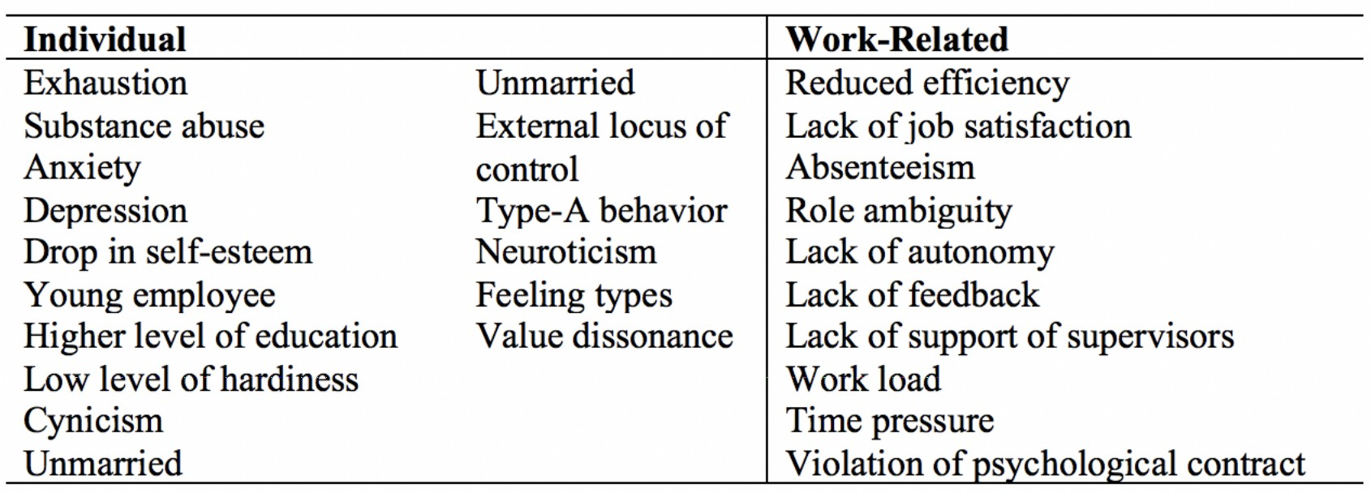

In the helping professions literature, the professions that are synergistic with military attrition include police officers, emergency medical technicians (EMTs), and clergy. What is common to these professions is that they require a high level of sustained effort and emotional energy that can counter the intrinsic value of helping others (Adams et al., 2017). The attrition literature here is

closely tied to the literature on burnout. Burnout is a maladaptive response to chronic job stressors that begins with an erosion of job engagement driven by increasing levels of exhaustion, cynicism, and ineffectiveness (Maslach et al., 2001). As measured on the Maslach Burnout Inventory, high cynicism in the helping professions has been shown to predict the intent to leave a job (Garcia et al., 2015) and high exhaustion to predict leaving a job (Weinberg et al., 1983). Burnout research has led to a multidimensional theory Maslach (2003, 1998) with three core dimensions.

      - The first is exhaustion; it represents the intrapersonal dimension of burnout and is the princi- pal quality and manifestation of burnout. Exhaustion results in feelings of being over extended and depleted of physical and emotional resources. Individuals feel their coping ability at work is severely taxed so much so that they are incapable of dealing with additional stress.
      - The second dimension, cynicism or depersonalization, represents the interpersonal dimension; consequences are negative, callous, or detached responses toward co-workers.
      - The third is the self-evaluation dimension; it refers to feelings of incompetence and lack of productivity at work (Maslach et al., 2001).

According to Maslach et al. (2001), the burnout process starts with the erosion of job engage- ment, when ...energy turns into exhaustion, involvement turns into cynicism, and efficacy turns into ineffectiveness. More recent burnout research has extended the model to a continuum of well-being, from a positive state of mind characterized by energy, involvement, and efficacy at one end, to a negative state of mind at the opposite end, characterized by exhaustion, cynicism, and inefficiency and the erosion of job engagement (Schaufeli et al., 2009).
Recent research on burnout has begun to integrate the degree of fit between the worker and key situational aspects of the workplace–workload, control, reward, community, fairness, and values. Burnout arises from chronic mismatches betweesn the worker and these situational aspects (Maslach et al., 2001; Shirom, 2011). Wilcox (2000) has hypothesized that burnout may lead to the attrition of trained military personnel. Few studies prior to 2000 examine burnout in the military. The three studies cited in her paper examined burnout among military medical professionals as does the more recent study by Garcia et al. (2015). Garcia et al. (2015) looked at burnout among Veteran Administration psychiatrists and concluded that by mitigating the areas of the work place that are the precursors to burnout the federal government could save taxpayers the substantial costs associated with staff attrition. These precursors include workplace characteristics such as unfair treatment by supervisors and insufficient resources.
Many of the theoretical constructs that have been associated with the study of military attrition (Weiss et al., 2003; Schneider et al., 2011) seem closely related to Maslach’s burnout theory. For example, both Weiss et al. (2003) and Schneider et al. (2011) include commitment as the focal point in their framework for studying military attrition. Commitment includes the cohesive bond

that a Soldier feels toward their fellow Soldiers and unit, which overlaps with the interpersonal burnout dimension of cynicism. The intrapersonal burnout dimension of exhaustion is related to the attrition constructs of context evaluation, in particular job satisfaction, and coping effectiveness, in particular stress and self-efficacy. Further, attrition in the military and Maslach’s burnout theory both contextualize the worker experience in the work place and recognize that accumulated experiences over time are key drivers of attrition and burnout.

Attrition or Turnover in Management

In the management literature, attrition is called turnover. Turnover captures employee separations from an organization and consists of several types, including resignations, retirements, discharges, reductions-in-force, deaths, and inter-agency transfers. Turnover correlates with trends in aggregate data such as labor market trends, called a base rate, which are useful for making comparisons, such as across industry sectors or studying trends. However, base rates, while useful for examining trends, do not inform about the reasons for the turnover (Morrell et al., 2001).
Turnover in an organization varies dramatically by industry sector (Holtom et al., 2008). The Bureau of Labor Statistics began calculating voluntary turnover rates in 2001, allowing for the comparison by industry sector. Accommodation and food services accounts for the highest annual turnover fluctuating between 38 and 50 percent, followed by retail trade that fluctuates between 26 and 35 percent. As the professional nature of industries increase, annual turnover rates hover at much lower rates, e.g. around 12 to 15 percent for educational services BLS JOLTS Survey results for 2011-2015 (http://www.bls.gov/news.release/jolts.t18.htm).
Turnover is expensive and disruptive for organizations. As a result, the interest is strong, and the literature is vast. These advances in understanding turnover (Holtom et al., 2008, 2013) include the addition of improved individual difference measures for predicting turnover, such as the effects of personality and motivation; more focus on variables that capture social contexts and interpersonal relationships and relational perspectives such as exchanges between leaders and subordinates (Mossholder et al., 2005); identification of factors that explain why employees stay with an organization, such as commitment to an organization (referred to in the literature as embeddedness) (Mitchell and Lee, 2001); and the development of dynamic models of the turnover processes (Lee et al., 2004).
There are two basic dimensions of turnover: voluntary-involuntary and functional-dysfunctional (Holtom et al., 2008). Voluntary and involuntary refer to an employee choosing or being forced to leave an organization, respectively. Functional and dysfunctional refer to the situation when a low or high performing employee leaves, respectively (Abelson and Baysinger, 1984).
There are three types of variables that should be taken into account when studying turnover (see Table 6). These include external factors related to the economy, work-related factors related to pay, satisfaction, and opportunities, and individual characteristics, noting for example that there

are differences in turnover between males and females. The findings in the table are not absolute and can vary in strength, e.g., pay and employment perceptions are less consistently related to turnover in service organizations (Cotton and Tuttle, 1986).
Table 6: Correlates of Turnover.
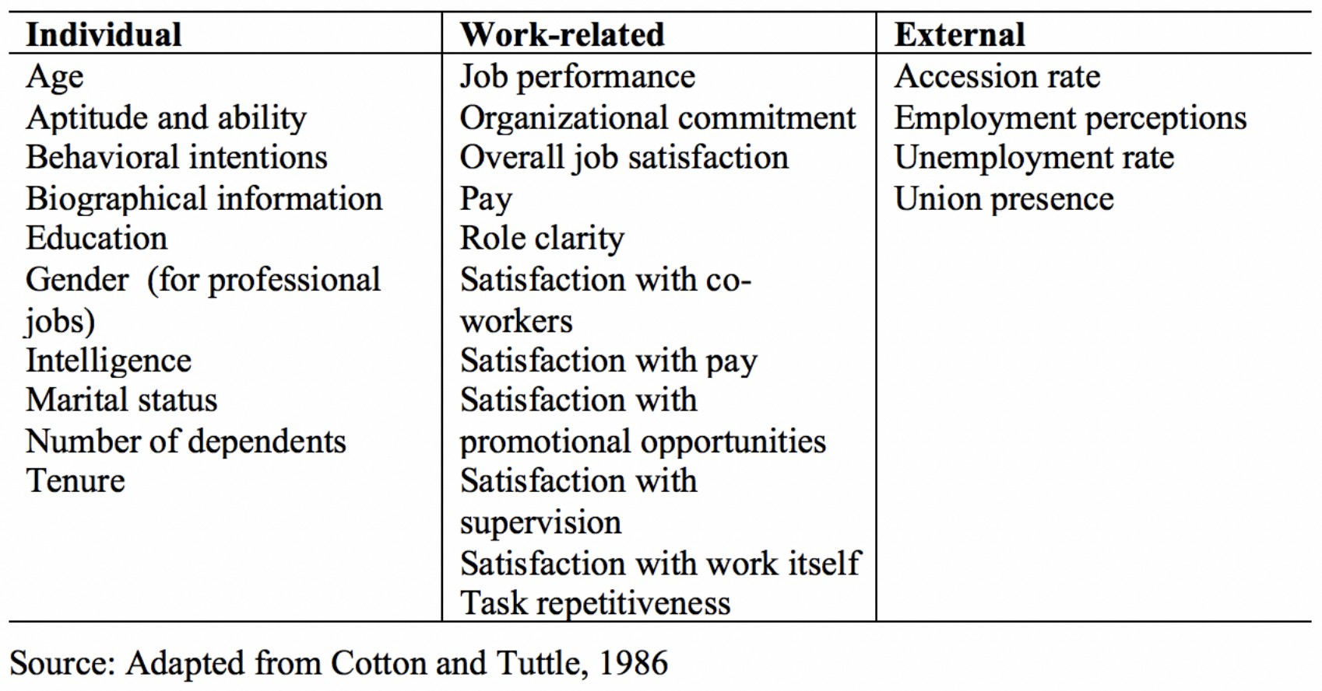

Over time, theories about turnover have expanded. Holtom et al. (2008) summarized trends that have informed and led to these expanded theories in the literature, each described in more detail below:
      - Individual characteristics, including the role of personality
      - Attitudes and coping with stress and change
      - Contextual considerations that take into account the individual and the organization, using models such as the Unfolding model (described below)
      - Focus on staying (embeddedness)
      - Dynamic modeling
Individual characteristics are examined to understand how self-confidence and decisiveness com- bined with ties to the organization and prior employment are related to turnover. A framework is needed to relate individual differences to other factors (Maertz Jr and Campion, 2004; Allen et al., 2005; Bauer et al., 2006).
Stress- and change-related attitudes focus on how acceptance of change is positively related to job satisfaction and negatively related to turnover intentions Wanberg and Banas (2000). Con- versely, psychological uncertainty and stress are positively related to turnover and can manifest

along multiple dimensions related to age, occupational status, co-worker support, absenteeism, pri- ority layoffs, and other factors such as work overload (Rafferty and Griffin, 2006; Podsakoff et al., 2007; Davis et al., 2015).
Studies using the Unfolding Model (Lee and Mitchell, 1994; Lee et al., 1999; Holtom and In- derrieden, 2006) include shocks (e.g. clash with supervisor or colleague, a better job offer, passed over for promotion, family reasons, reassignment, and mergers and acquisitions), scripts (a pre- existing plan of action), image violations (an individuals values and goals do not align with the organizations), job satisfaction (the decline that can occur if a person no longer feels intellectually challenged), and job search (seeking and weighing alternatives).
Each type of shock triggers a different set and ordering of reactions (called paths) towards turnover (or not). Understanding the kinds of shocks can provide insights into which paths lead to avoidable turnover and which do not, from the firms perspective (Holtom et al., 2005, 2013). For example, personal shocks that are positive lead to unavoidable leaving while negative shocks that are work related are avoidable. Shock-driven events lead to faster turnover and tend to happen earlier in a job, while job dissatisfaction-driven turnover takes longer (Holtom et al., 2013). The Unfolding Model holds promise for explaining turnover but needs to be tested for its applicability in different scenarios (Holtom et al., 2008).
Contextual considerations encompass attitudes and perceptions about satisfaction, engagement within an office, all of which are inversely related to turnover. For example, the diversity of the workforce at different levels and occupations and the perception of diversity are determinants of turnover but the relationship varies by gender and occupation. A firms pay distribution also affects turnover where high performing employees are more likely to leave if there is little differentiation in pay although commitment is a confounding factor (Panaccio et al., 2014). Perceived supervisory support had mixed effects across studies (Bauer et al., 2006). Contextual considerations also focus on organizational-level consequences of turnover, such as unit-level satisfaction and attitudes (Shaw et al., 2005a).
Similar to unit-level consequences, culture, prestige, and climate each play a role separately and in combination. The concept of social capital is used to explain the complexity of the dynamics that result when turnover occurs. The effect on employee productivity is nonlinear; at low levels of turnover, productivity remains low, as new ideas are not infused into the organization. As turnover begins to increase, the changes increase productivity as employees take on new roles and organizations find ways to offset the disruptions (Shaw et al., 2005b; Segrest et al., 2015). Finding a balance of some but not too much turnover appears to keep employees and organizations engaged. When the focus shifts to staying in place of leaving, the concept of embeddedness is useful.
Embeddedness is a mix of factors that influence whether an employee stays in their job. The concept represents links that the employee has to the community and others in the unit or organization, how they fit in, and the sacrifices they would make both on and off the job if they left (Mitchell and Lee,

2001; Mitchell et al., 2001). This construct can be incorporated into different models such as the Unfolding Model to understand the factors that keep high performing employees while encouraging low performing employees to leave. Although embeddedness varies by demographic group, it is still a strong predictor of employee retention (Mallol et al., 2007; Peltokorpi et al., 2015; Bergiel et al., 2014; Purba et al., 2016). Embeddedness is also affected by the quality of the supervisor relationship and the extroverted/introverted profile of the employee (Bauer et al., 2006; Purba et al., 2016), the quality of the development climate (Spell et al., 2014), and human resource practices, such as onboarding, leadership development, compensation, and employee relations (Schmidt et al., 2018; Selden and Sowa, 2015).
Dynamic modeling of the turnover process focuses on how turnover changes over time. There are many different types of models for examining trends in important behaviors such as attitudes, the different phases of job search (passive, scanning, and focused), and the different cognitive changes that employees undergo when changing jobs (Steel, 2002; Bentein et al., 2005; Kammeyer-Mueller et al., 2005). Dynamic models incorporate these kinds of changes over time (Holtom et al., 2013; Jiang et al., 2012; Peltokorpi et al., 2015; Sturman and Trevor, 2001; Weller et al., 2009). This area of research is promising for understanding turnover in the military because it takes into account multiple factors and how they change over time.
Expansion of earlier research focuses on the relationship between turnover, commitment, and job satisfaction, and has continued to provide new insights about why people may or may not leave their job (Holtom et al., 2013; Ellingson et al., 2016). More recent studies now focus on why people stay (retention) as well as why they leave (attrition). Turnover is now examined more broadly and describes factors that influence whether a person stays or leaves a job and how the reactions to these factors may change over time, such as where they are in their job search, or their level of skill, and stage of their life (Liu et al., 2012; Hesford et al., 2016). The models and approaches are more complex and provide deeper insights into this topic, such as understanding why early turnover may be more detrimental to an organization than turnover by employees who have been with the firm for longer periods of time.

Attrition in Education

In the education literature, research synergistic to military attrition covers three domains, high- school dropout, college persistence, and teacher attrition and retention (attrition tends to occur within the first five years of teaching). Across these domains many factors are identified that drive student and teacher attrition, including both individual, contextual factors, and changes over time. For example, the age groups are similar (ages 14-25) and thus the individuals who enlist face many of the same challenges as high school and college students and young teachers. They are in new and demanding environments, they must make decisions about their career and life trajectories, and they are still growing up. The definition of attrition varies across high-school dropout, college

persistence, and teacher turnover.

      - High-school dropout is defined consistently as leaving school prior to graduation. There are multiple ways to increase the specificity of the measure in time (e.g., over one year period) or the population of interest (e.g., tracking 9th graders through high school) (Dup´er´e et al., 2015; Stearns, 2011; Council et al., 2011).
      - College attrition is usually presented in terms of persistence to complete college. It is compli- cated in terms of how attrition-like behaviors are operationalized and has been largely defined as persistence in enrollment each semester; withdrawal from the institution prior to gradu- ation, including students that may have transferred to another institution; and withdrawal from the institution not including transfers (Kuh et al., 2006; Allen, 1999; Cabrera et al., 1993).
      - New teacher attrition is generally defined as leaving the profession in the first five years. An understanding of what factors influence expectations and intentions to leave or stay is important (Bean, 1985; Flores and Day, 2006; Schaefer et al., 2012) as well as how variation in local context influences teachers to stay or leave (Dup´er´e et al., 2015). Many factors have a weak association with teacher attrition and there is not just one factor that explains attrition (Borman and Dowling, 2008).

Similar to studying attrition of Soldiers, there is a need to characterize attrition as a process versus a single event in time and to incorporate individual and contextual factors of attrition and their interactions over time in future research (Schaefer et al., 2012; Rumberger and Lim, 2008). The interaction of individual characteristics and contextual factors and how these interactions change over time provide the opportunity to improve our understanding of why students drop out or persist to finish high school or college and why teachers leave or stay in their profession. Early warning systems that capture factors before and during the educational process may be effective (Allensworth and Easton, 2005; Regional Educational Laboratory, 2011). These kinds of indicators might also be useful for anticipating military attrition.

B.3 Summary and Conclusions
This literature review addresses how other social and behavioral science theories and methods across several disciplines may afford a clearer understanding of questions about Army attrition. The three areas of non-military literature reviewed are the helping professions (in this review, emergency med- ical technicians, police, and clergy), management, and education (teachers and students) because of their relevancy to understanding attrition of enlisted Army Soldiers. These areas have some focus on theory and include psychology (similar to the military literature) and subject matter expertise.

The theories and methods presented above provide alternative perspectives on why an individual stays or leaves a position and how these factors change over time.
Traditionally, research on attrition focused on job satisfaction and while that is still an impor- tant factor, both the military and civilian research has evolved to include contextual factors and the interdependence of these factors. In the military literature, contextual factors such as being unmarried, fewer years of military experience, and lower unit or organizational support were sig- nificant predictors of attrition. Parallel notions in the civilian literature include contextual factors such as individual and organizational characteristics (demographic characteristics and personality profiles, the availability of professional support, collaboration across teams, salary, professional development) and how these factors and their interactions vary over time.
An example of a management model that embraces the advances in theory is the Unfolding Model. This model allows for differences in what triggers attrition, such as different kinds of internal and external shocks or other factors such as persistent job dissatisfaction; it models the different pathways to examine what factors firms can anticipate to avoid attrition of employees. The Unfolding Model is representative of the emergence of dynamic and hierarchal models in the literature that account for multiple dimensions including time.
While the theories and models have matured, there are still gaps in the literature especially in terms of advanced analytic methods and the requisite data needed to drive them. Work remains to create frameworks to test applications of the new dynamic and hierarchal models and contex- tual factors needed to take into account prior factors, such as pre-deployment mental health in the military or being laid off in an earlier job. Historically research in these areas has relied on relatively small surveys or a limited number of interviews but recently research is emerging that takes advantage of access to vast amounts of administrative data and longitudinal surveys. These relatively new data sources combined with the increasing analytics capacity that embraces advances in statistical measurement and modeling are being tested to assess if hard-to-solve problems such as military attrition of enlisted Army Soldiers are solvable. As described in this report, addressing these gaps is the focus of our research.

